12/2/2020

Abhilash Bahl

Applied Econometrics and Time Series Analysis – Project

BUAN 6312.001

Contents

Exploratory Data Analysis: 2

Data Description: 2

Summary Statistics (Introduction to 11 variables): 3

Trends over time: 9

Trends over states: 11

Trends over the years 1977 – 1999 across states: 13

Correlation chart: 18

Hypothesis Testing: 19

Regression Analysis: 24

Analysis for violent crime rate: 24

Analysis for robbery rate: 40

Random Effects Model: 52

Conclusion: 52

# Exploratory Data Analysis:

## Data Description:

The data consists of a balanced panel data on 51 US States (including District of Columbia) for the years 1977 - 1999. Definition of each variable is provided below.

|  |  |
| --- | --- |
| VARIABLE | DEFINITION |
| vio | Violent crime rate (incidents per 100,000 members of the population) |
| rob | Robbery rate (incidents per 100,000 members of the population) |
| mur | Mruder rate (incidents per 100,000 members of the population) |
| shall | = 1; if the state has a shall carry law in effect in that year  = 0; otherwise |
| incarc_rate | Incarceration rate in the state in the previous year (sentenced prisoners per 100,000 residents) |
| density | Population per square mile of land area, divided by 1000 |
| avginc | Real per capita personal income in the state, thousands of dollars |
| pop | State population, in millions of people |
| pm1029 | Percent of state population that is male, ages 10 to 29 |
| pb1064 | Percent of state population that is black, ages 10 to 64 |
| pw1064 | Percent of state population that is white, ages 10 to 64 |
| stateid | ID number of states |
| year | Year (1977-1999) |

## Summary Statistics (Introduction to 11 variables):

1. ***vio:*** Violent crime rate (incidents per 100,000 members of the population)

|  |  |
| --- | --- |
| Mean | 503.074 |
| Standard Deviation | 334.277 |
| Minimum | 47 |
| Maximum | 2921.8 |

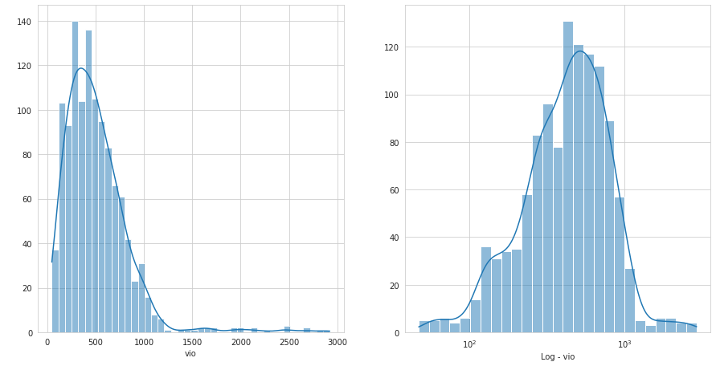

Figure 1

From the histogram for violent crime rate, it is observed that this variable has a positively skewed distribution. Since the violent crime rate is skewed towards the right, we check if the distribution can be made approximately normal using a log transformation method.

1. ***mur:*** Murder rate (incidents per 100,000 members of the population)

|  |  |
| --- | --- |
| Mean | 7.665 |
| Standard deviation | 7.523 |
| Minimum | 0.2 |
| Maximum | 80.599 |

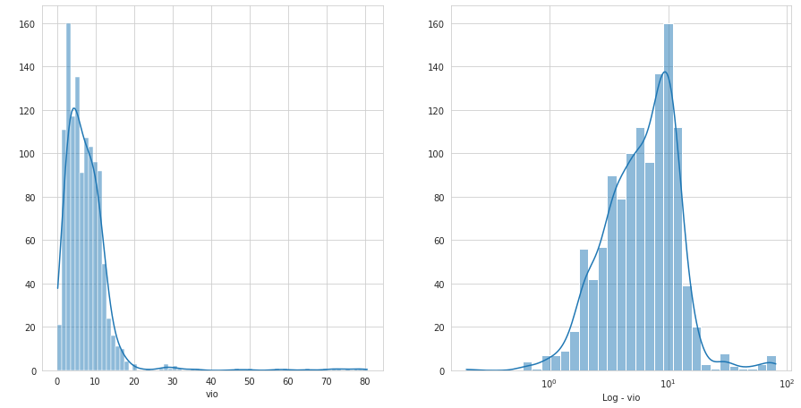

Figure 2

From the histogram for murder rate, it is observed that this variable has a positively skewed distribution. Since murder rate is skewed towards right, we check if the distribution can be made approximately normal using a log transformation method.

1. ***rob****:* Robbery Rate (incidents per 100,000 members of the population)

|  |  |
| --- | --- |
| Mean | 161.820 |
| Standard Deviation | 170.510 |
| Minimum | 6.4 |
| Maximum | 1635.099 |

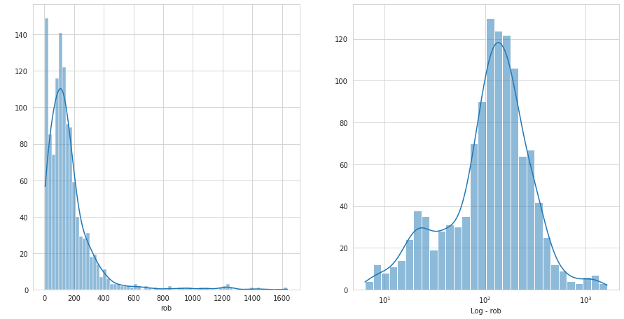

Figure 3

From the histogram for robbery rate, it is observed that this variable has a positively skewed distribution. Since robbery rate is skewed towards the right, we check if the distribution can be made approximately normal using a log transformation method.

1. ***incarc_rate****:* Incarceration rate in the state in the previous year (sentenced prisoners per 100.000 residents)

|  |  |
| --- | --- |
| Mean | 226.579 |
| Standard Deviation | 178.888 |
| Minimum | 19 |
| Maximum | 1913 |

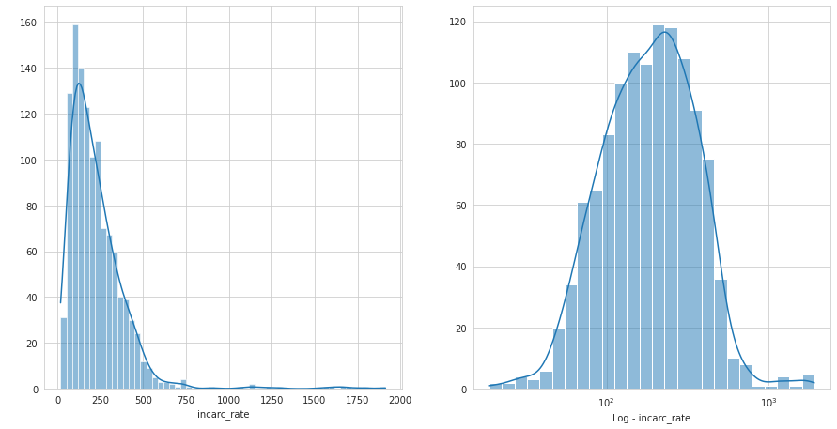

Figure 4

From the histogram for incarceration rate, it is observed that this variable has a positively skewed distribution. Since incarceration rate is skewed towards the right, we check if the distribution can be made approximately normal using a log transformation method.

1. ***pb1064:*** Percent of state population that is black, ages 10 to 64

|  |  |
| --- | --- |
| Mean | 5.336 |
| Standard Deviation | 4.886 |
| Minimum | 0.248 |
| Maximum | 26.979 |

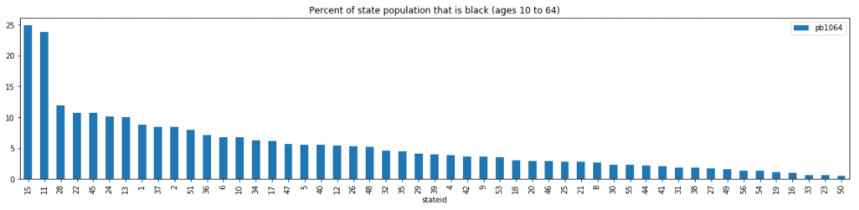

Figure 5

State id 15 and 11 have a high percentage of black male population in the ages 10 to 64, whereas state id 50 has the lowest percentage of black male population that is aged 10 to 64.

1. ***pw1064:*** Percent of state population that is white, ages 10 to 64

|  |  |
| --- | --- |
| Mean | 62.945 |
| Standard Deviation | 9.761 |
| Minimum | 21.780 |
| Maximum | 76.526 |

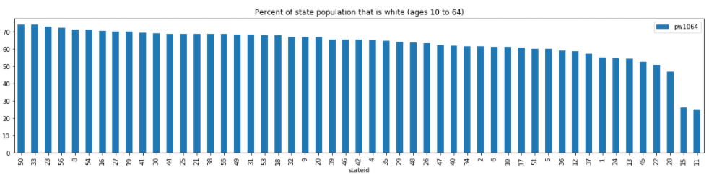

Figure 6

State id 50 and 33 have the highest percentage of white male population, whereas state id 15 and 11 have the lowest percentage of white male population aged 10 to 64. *Both states 50, 33 have amongst the lowest population for black.*

1. ***pm1029:*** Percent of state population that is male, ages 10 to 29

|  |  |
| --- | --- |
| Mean | 16.081 |
| Standard Deviation | 1.732 |
| Minimum | 12.214 |
| Maximum | 22.353 |

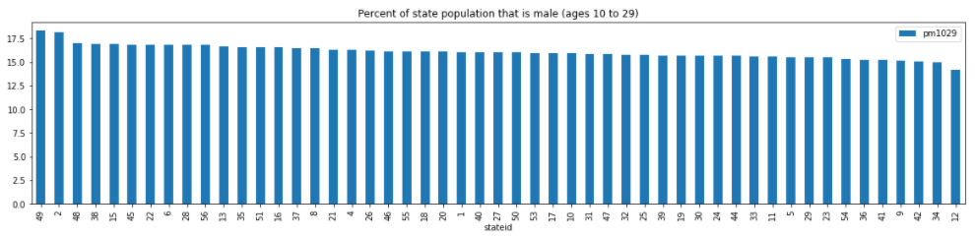

Figure 7

State id 49 and 2 have the highest percentage of male population aged 10 to 29, whereas state id 12 has the lowest percentage of male population aged 10 to 29.

1. ***pop:*** State population, in millions of people

|  |  |
| --- | --- |
| Mean | 4.816 |
| Standard Deviation | 5.252 |
| Minimum | 0.402 |
| Maximum | 33.145 |

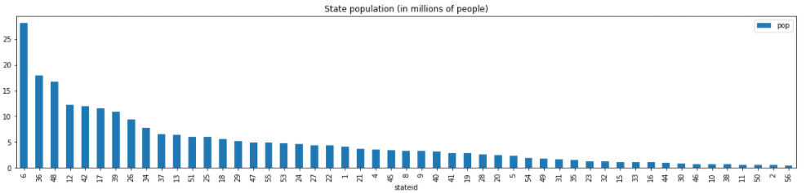

Figure 8

State id 6 has the highest population followed by state id 36, whereas state id 2 and 56 have the lowest population, in millions of people.

1. ***avginc:*** Real per capita personal income in the state, in thousands of dollars

|  |  |
| --- | --- |
| Mean | 13.725 |
| Standard Deviation | 2.555 |
| Minimum | 8.555 |
| Maximum | 23.647 |

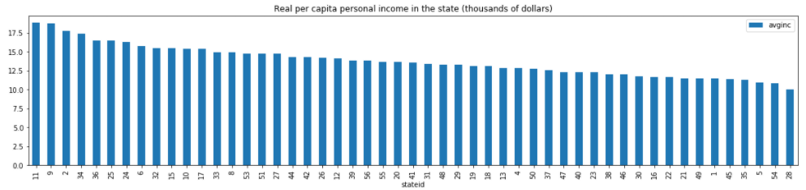

Figure 9

State id 11 and 9 have the highest real per capita personal income, whereas state id 28 has the lowest real per capita personal income, in thousands of dollars.

1. ***density:*** population per square mile of land area, divided by 1000

|  |  |
| --- | --- |
| Mean | 0.352 |
| Standard Deviation | 1.355 |
| Minimum | 0.0007 |
| Maximum | 11.102 |

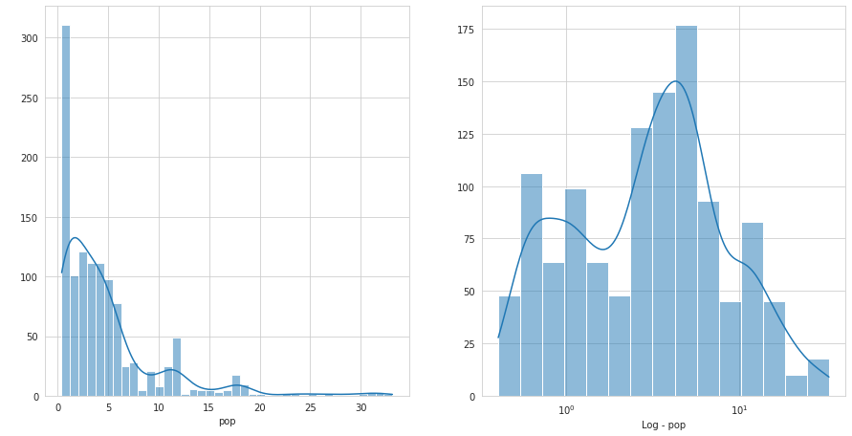

Figure 10

From the histogram for population density, it is observed that this variable has a positively skewed distribution. Since population density is skewed towards the right, we check if the distribution can be made approximately normal using a log transformation method.

1. ***shall:*** = 1, if a state has shall carry law in effect in that year.

           = 0, Otherwise

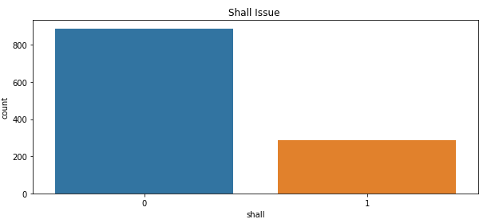

Figure 11

It can be observed that the majority of the dataset does not have a shall issue law in place.

## Trends over time:

1. *Shall law over time:*

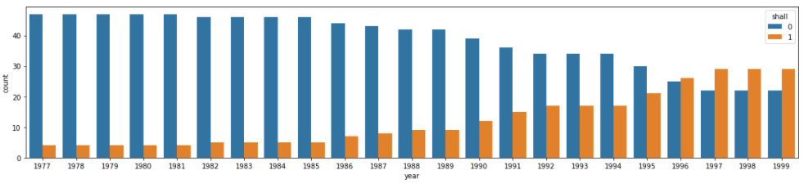

Figure 12

From the above distribution, it is observed that as we move from 1977 to 1999, more states have been bringing shall-issue laws into effect.

1. *Trend of crime rates (violent crime rate, murder rate, robbery rate) over the years 1977 - 1999:*

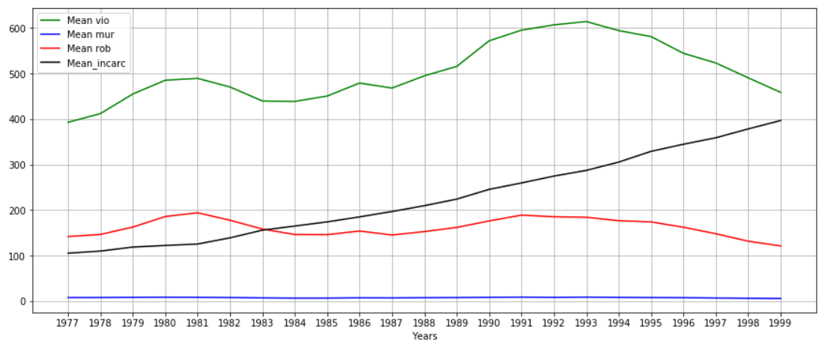

Figure 13

According to the average plots for violent crime rate, murder rate, robbery and incarceration rate:

1. Average violent crime rate was the highest in 1993 and lowest in 1977 across all US states.
2. Average robbery rate was the highest in 1991 and lowest in 1999 across all US states.
3. Average murder rate is the lowest of all the three crime rates and has a constant trend throughout all the years across all US states.
4. Average incarceration rate was the lowest in 1977 and highest in 1999, it also shows a continuous increasing trend as we move from 1977 to 1999.

1. *Trend for percentage of state population that is black(aged 10 to 64), that is white(aged 10 to 64), that is male(aged 10 to 29):*

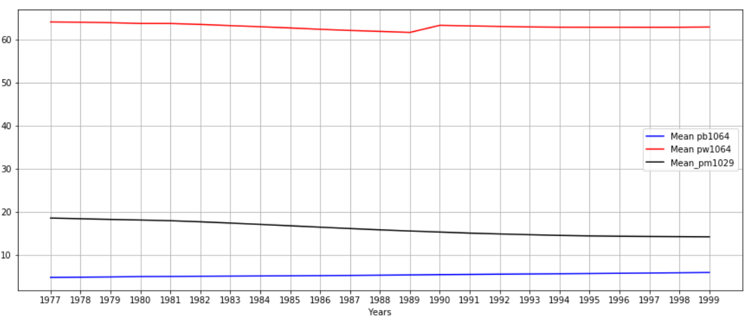

Figure 14

According to the above plots of percentage of state populations:

1. Percentage of the state population that is black, aged 10 to 64, has an approximate constant trend over the years 1977 - 1999.
2. Percentage of the state population that is white, aged 10 to 64, decreased from 1977 to 1989, increased from 1989 to 1990 and then has a constant trend over the years 1991 - 1999.
3. Percentage of the state population that is male, aged 10 to 29, has been decreasing/has a downward trend from 1977 - 1999.
4. *Trend for average income over the years 1977 - 1999:*

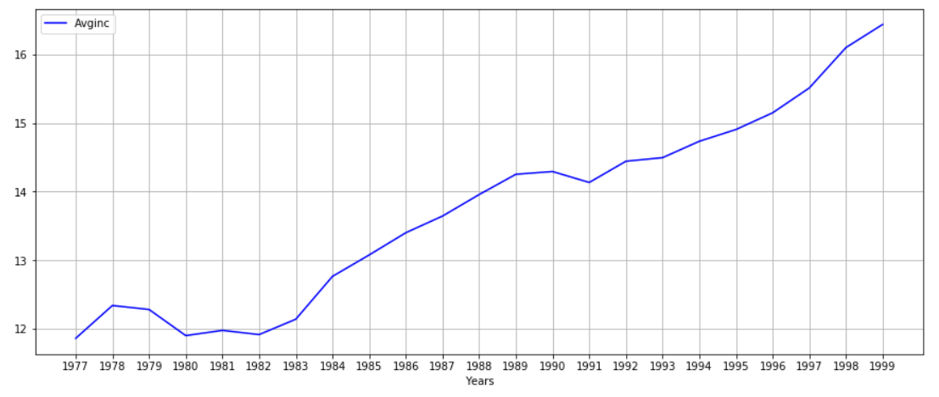

Figure 15

Average income was the lowest in 1977 and 1980, and the highest in 1999. This plot shows that average income has an increasing trend overall with some dips in the years 1980, 1982, 1991.

## Trends over states:

1. *Violent Crime Rate:*

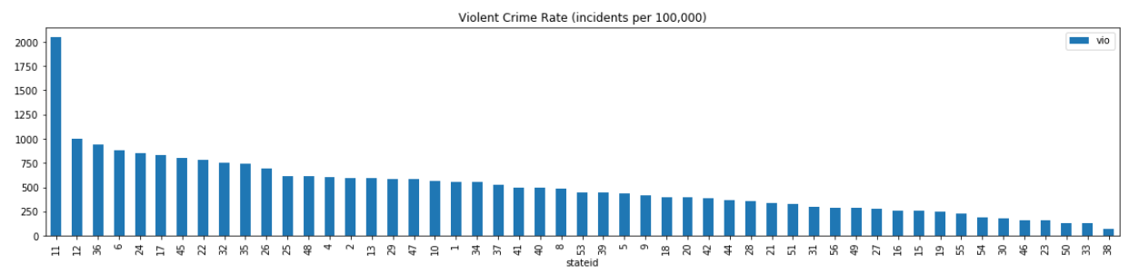

Figure 16

State id 11 has the highest violent crime rate followed by state id 12, whereas state id 33 & 38 have the lowest violent crime rate.

1. *Murder Rate:*

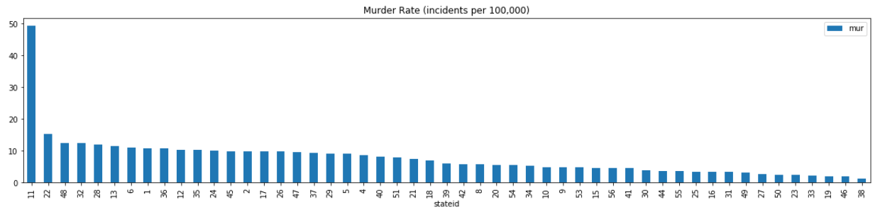

Figure 17

State id 11 has the highest murder rate followed by state id 22, whereas state id 46 & 38 have the lowest murder rate.

1. *Robbery Rate:*

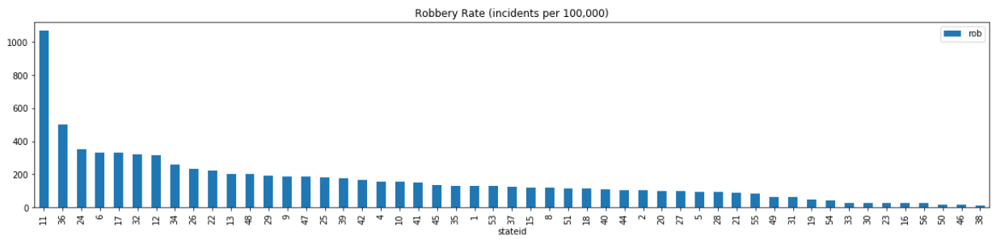

Figure 18

State id 11 has the highest robbery rate, whereas state id 46 & 38 have the lowest murder rate.

1. *Incarceration Rate:*

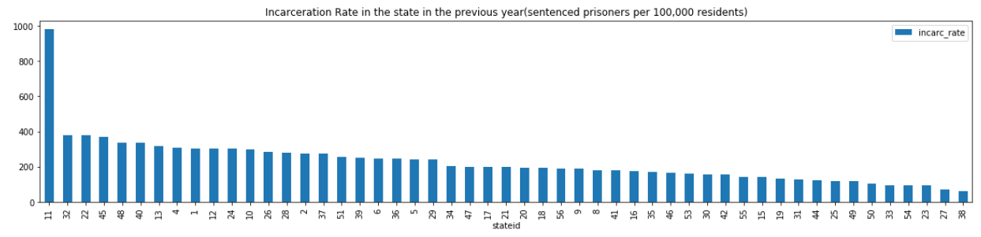

Figure 19

State id 11 has the highest incarceration rate, whereas state id 27 & 38 have the lowest incarceration rate.

1. *Population:*

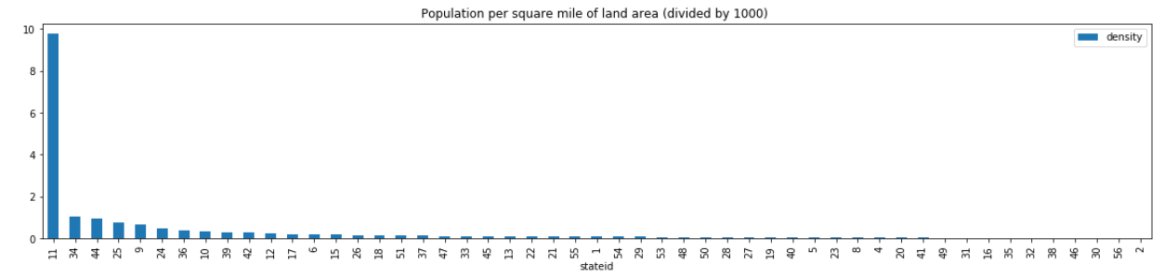

Figure 20

State id 11 has the highest population density, whereas state id 56 & 2 have the lowest population densities.

*Inferences from above plots:*

1. *State id 11 has the highest percentage of black population (age 10 to 64) along with the lowest percentage of white population (age 10 to 64) and the lowest percentage of male population (age 10 to 29).*
2. *State id 11 has the highest violent crime, robbery, murder and incarceration rates.*
3. *State id 11 also has the highest average income and the highest population density.*
4. *State id 50 and 33 have the highest percentage of white population (age 10 to 64) and the lowest percentage of black population (age 10 to 64).*
5. *State id 50 also has a low population density, low incarceration rate, low violent crime rate, low murder rate, low robbery rate and a low average income.*
6. *Shall law:*

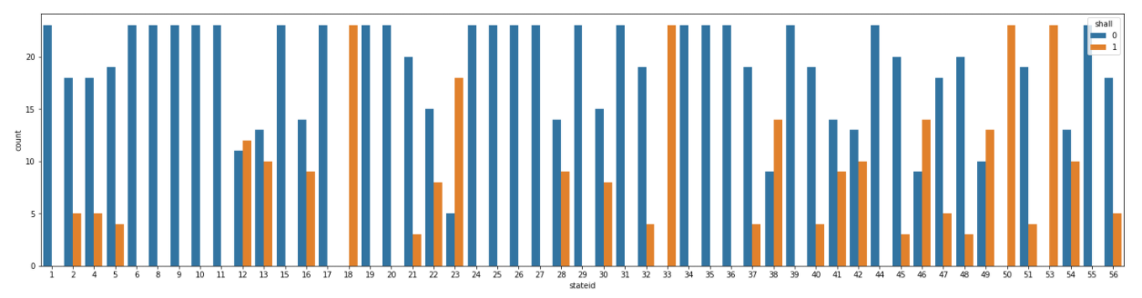

Figure 21

**States that never issued shall law:** 1, 6, 8, 9, 10, 11, 17, 20, 24, 25, 26, 27, 29, 31, 34, 35, 36, 39, 44, 55

**States that always had a shall law:** 18, 33, 50, 53

*Point to note: State id 50 has always had shall law, has the highest percentage of white population, low crime rates, low incarceration rate, low population density, and low average income.*

## Trends over the years 1977 – 1999 across states:

1. *Average income over the years across states with and without shall law:*

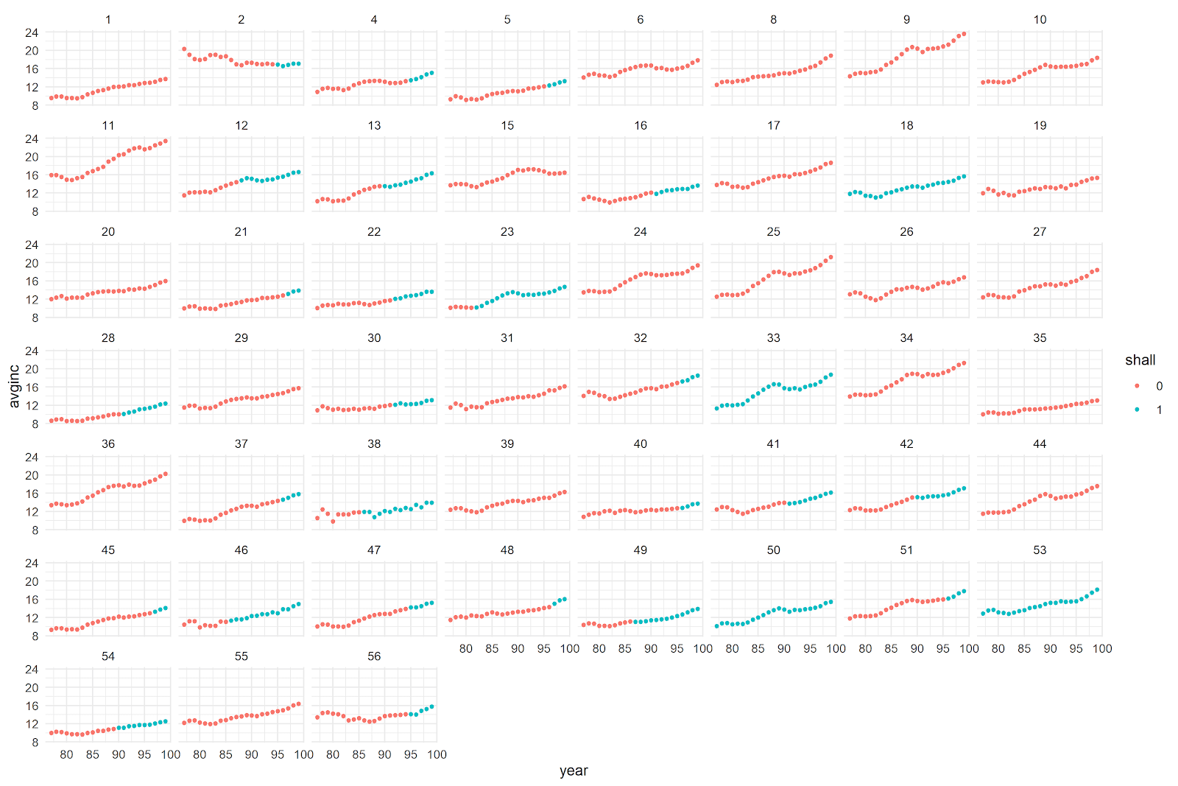

Figure 22

1. State id 2 is the only state where the average income has declined over the years 1977 – 1999. Average income for state id 30 and 56 has not changed much over the years.
2. For all other states, there has been a steady upward trend over the years 1977 – 1999. There does not seem to be a significant impact of introducing shall laws to the state’s average income overall.
3. *Incarceration rate over the years across states with and without shall law:*

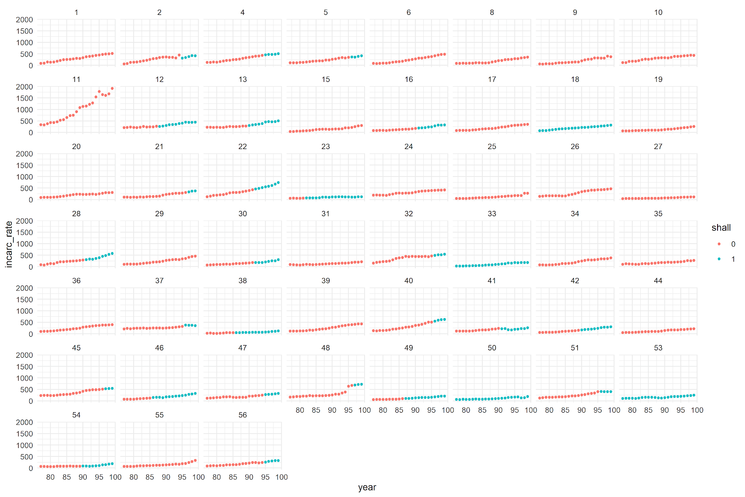

Figure 23

1. From the chart above, it can be observed that for state id 11, incarceration rate has had an upward trend over the years and this state has never introduced a shall law for the given years.
2. There has not been much effect of introducing shall laws in certain states except for state id 41 and 37, where incarceration rate declined as shall laws were put into effect.
3. *Incarceration rate is lowest in state id’s: 23, 27, 31, 35, 38, 44, 49, 51, 54*
4. *Murder rate over the years across states with and without shall laws:*

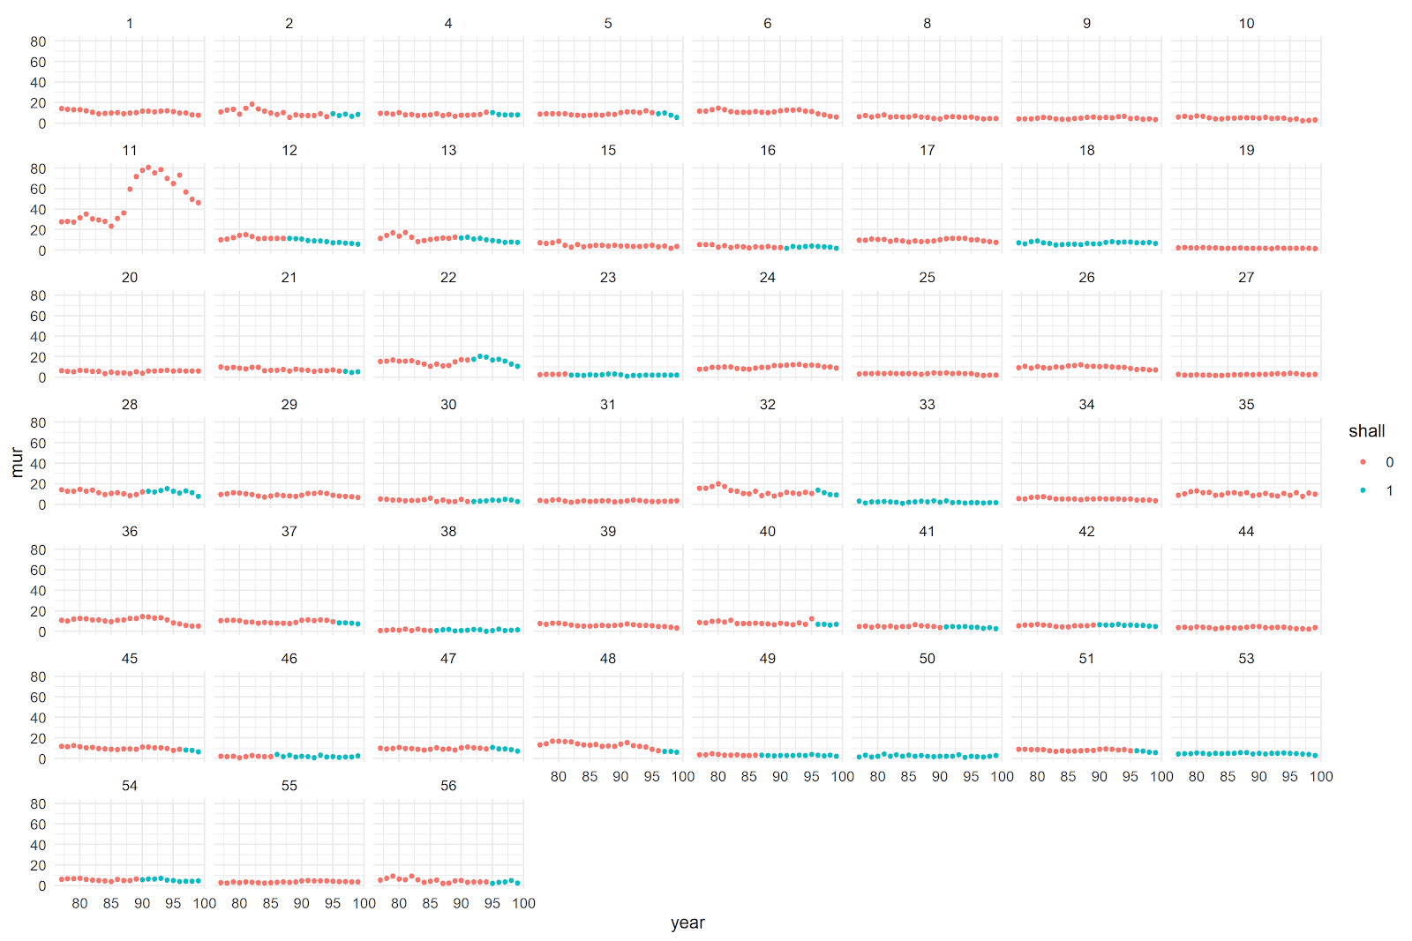

Figure 24

1. State id 11 has had the highest murder rate over the years.
2. Although, introducing shall law is not impacting the murder rate much overall but in some states; 12, 13, 22, 28, 32, 47, 48 – there is a visible decline after shall law is put into effect. This impact can be due to some other factors which need to be investigated further in this analysis.
3. *Robbery rate over the years across states with and without shall laws:*

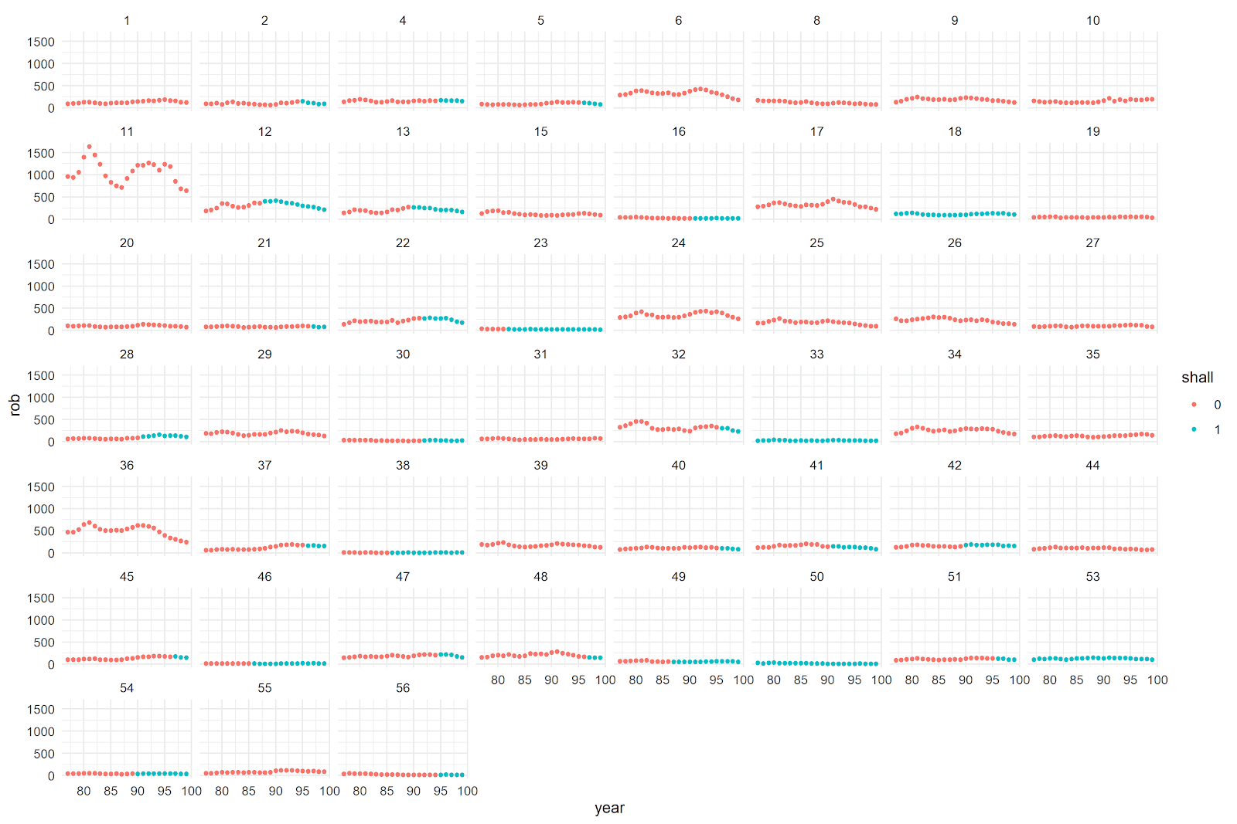

Figure 25

1. Robbery rate for state id 11 is the highest although it has a downward trend.
2. For some states; 12, 13, 22, 32, 56, 48 – putting shall law into effect has resulted in reduction of robbery rate.
3. For states; 18, 33, 50, 53 – shall law has always been in place, and there is very little variation in robbery rate.
4. States that have never accepted shall law have more variation in robbery rate.
5. *Violent crime rate over the years across states with and without shall laws:*

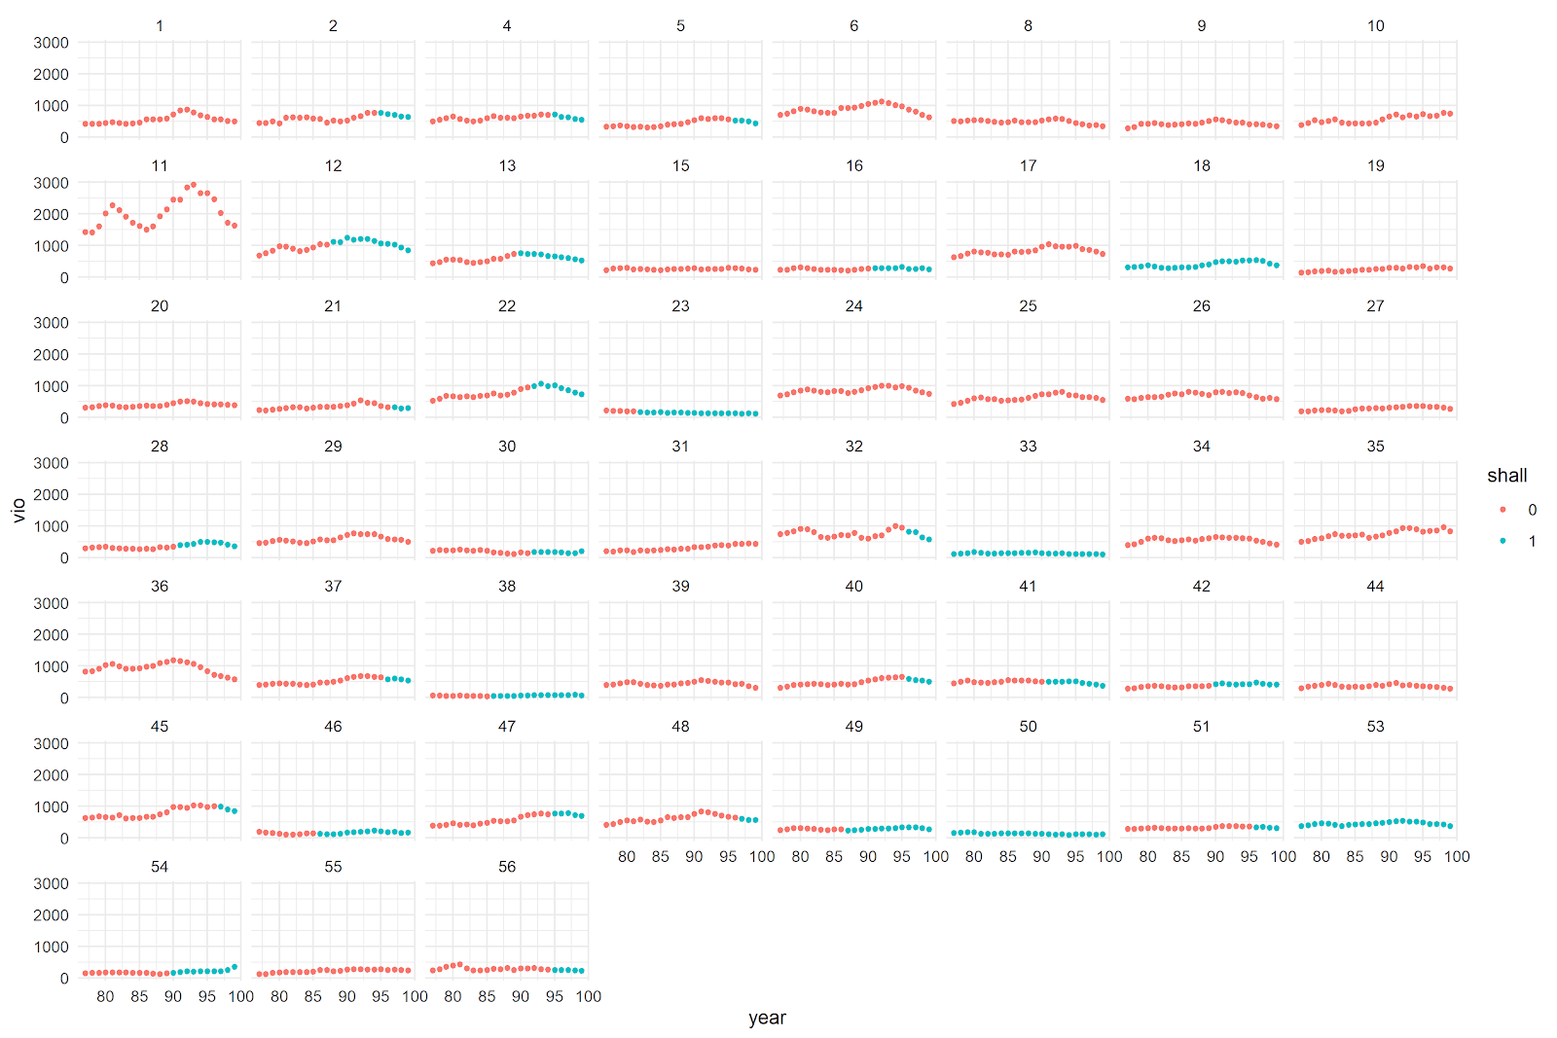

Figure 26

1. It can be observed from this chart as well as the previous ones that state id 11 has the highest crime rate; robbery, murder or violent crime.
2. For states; 2, 4, 12, 13, 22, 32, 37, 47 - violent crime rate has a downward trend after shall law has been put into effect. Although, for other states introducing shall law has not made any major impact.
3. For state id 28, violent crime rate increased with the introduction of shall law for a few years and then decline again.

## Correlation chart:

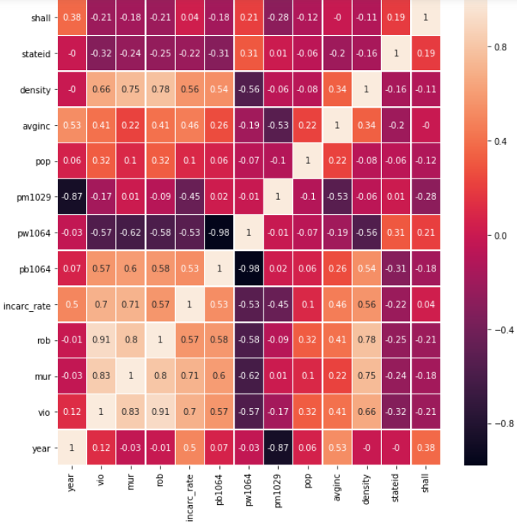

Figure 27

1. There is a very high negative correlation between pb1064 and pw1064 of -0.98, which means that states with higher percentage of black population tend to have lower percentage of white population and vice-versa.
2. All three types of crime rates have a high positive correlation among themselves as well as with incarceration rate.
3. Population density has fairly positive correlation with all three types of crime rates as well as with incarceration rates.
4. Pw1064 has fairly negative correlation with all three types of crime rates as well as with incarceration rates, while the opposite is true for pb1064.
5. Population density has a positive correlation of 0.54 with pb1064 and a negative correlation of -0.56 with pw1064. This means that densely populated areas have a higher percentage of black population, and sparsely populated areas have a higher percentage of white population.

# Hypothesis Testing:

On the basis of various visualizations from exploratory data analysis, the following hypothesis are being tested to understand the significance of some important variables with and without shall law.

1. Percentage of black population (age 10 to 64) is significantly different with and without shall law.

H0: Percentage of black population (age 10 to 64) is not significantly different with and without shall law

H1: Percentage of black population (age 10 to 64) is significantly different with and without shall law

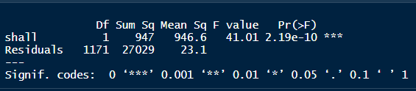

Figure 28

* Percentage of black population (age 10 to 64) varies significantly with and without shall law.

Adding an interaction between shall and state id:

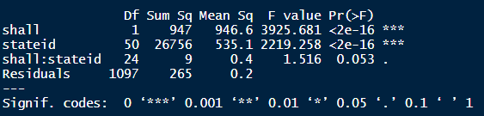

Figure 29

* Percentage of black population (age 10 to 64) varies significantly with and without shall law across states.

1. Percentage of white population (age 10 to 64) is significantly different with and without shall law.

H0: Percentage of white population (age 10 64) is not significantly different with and without shall law

H0: Percentage of white population (age 10 64) is significantly different with and without shall law

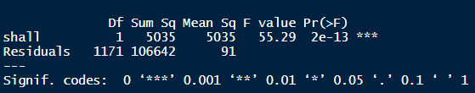

Figure 30

* Percentage of white population (age 10 to 64) varies significantly with and without shall law.

Adding an interaction between shall and state id:

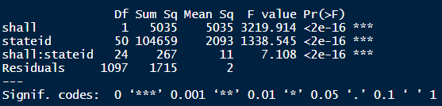

Figure 31

* Percentage of white population (age 10 to 64) varies significantly with and without shall law across states.

1. Population density is significantly different with and without shall law.

H0: Population density is not significantly different with and without shall law

H1: Population density is significantly different with and without shall law

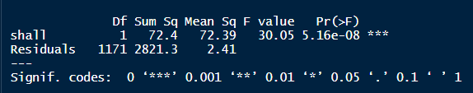

Figure 32

* As the p-value is very small, we reject the null hypothesis and conclude that population density is significantly different with and without shall law.

Adding an interaction between shall and state id:

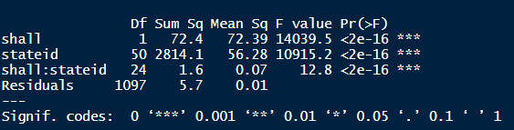

Figure 33

* Population density is significantly different with and without shall law across states.

1. Violent crime rate is significantly different with and without shall law.

H0: Violent crime rate is not significantly different with and without shall law

H1: Violent crime rate is significantly different with and without shall law

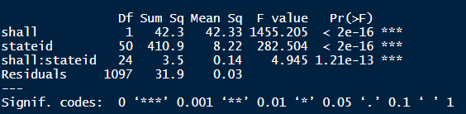

Figure 34

* As the p-value is very small, we reject the null hypothesis and conclude that violent crime is significantly different with and without shall law across states.

1. Murder rate is significantly different with and without shall law.

H0: Murder rate is not significantly different with and without shall law

H1: Murder rate is significantly different with and without shall law

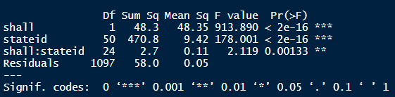

Figure 35

* As the p-value is very small, we reject the null hypothesis and conclude that murder rate is significantly different with and without shall law across states.

1. Robbery rate is significantly different with and without shall law.

H0: Robbery rate is not significantly different with and without shall law

H1: Robbery rate is significantly different with and without shall law

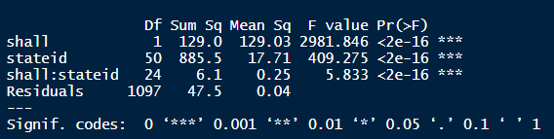

Figure 36

* As the p-value is very small, we reject the null hypothesis and conclude that robbery rate is significantly different with and without shall law across states.

1. Incarceration rate is significantly different with and without shall law.

H0: Incarceration rate is not significantly different with and without shall law

H1: Incarceration rate is significantly different with and without shall law

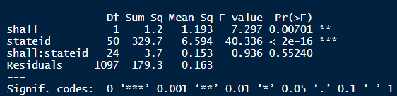

Figure 37

* Incarceration rate is significantly different with and without shall law, but the interaction effect of state id with shall is not statistically significant.

1. Do states that transitioned to shall law differ from the states that never transitioned to shall law?

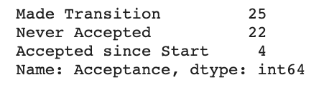

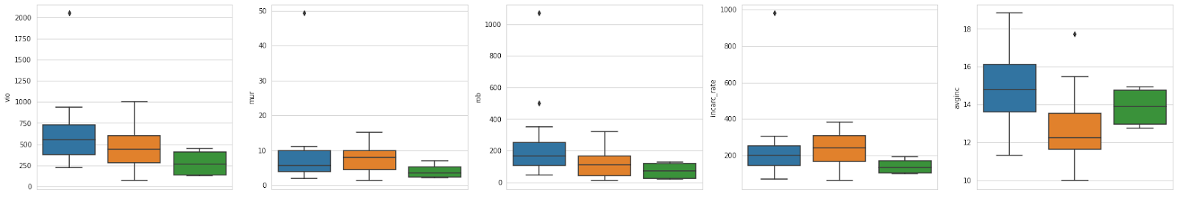

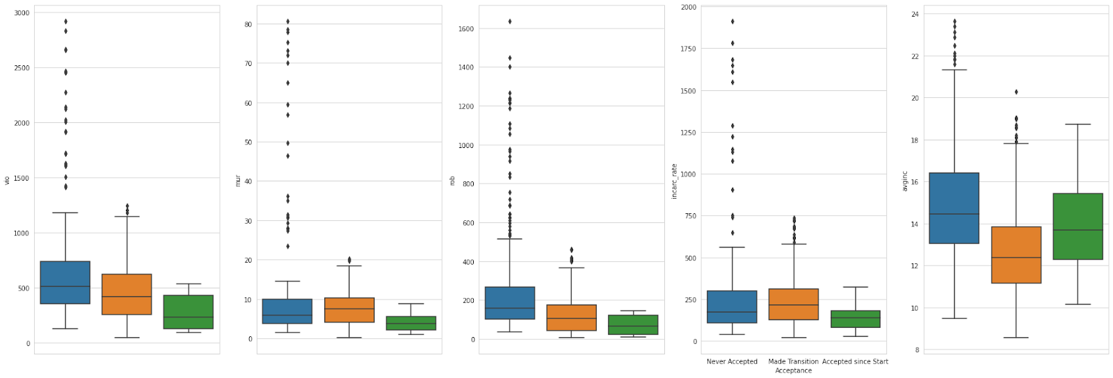

Figure 38

1. Based on the above plots, it can be inferred that states that did not transition to shall law tend to have higher income and states that made transition often have lower average income.
2. It is also observed that states that never transitioned to shall law tend to have higher rates of murder, violent crime and robbery. These states also have on average higher income and higher population density. We check two hypotheses here.

Vio = Acceptance

Vio = Acceptance + Average Income

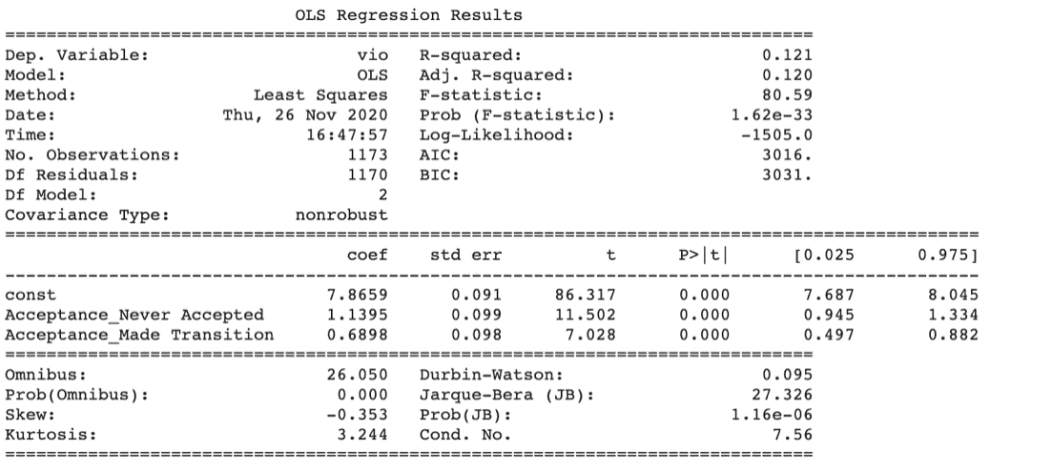

Figure 39

* We notice that there is significant different in violent crime rates in states that accepted shall laws and states that never accepted shall laws. States that never made transition have a significantly higher violent crime rate.

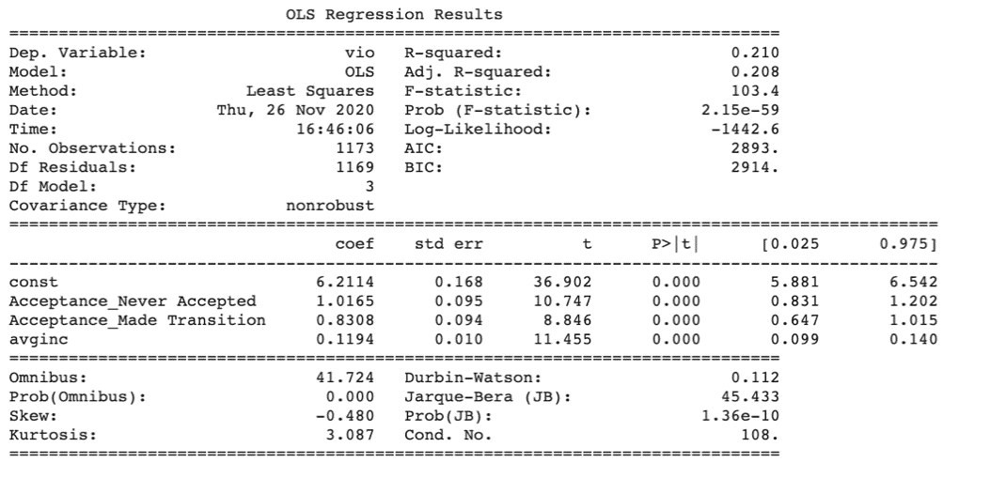

Figure 40

* Once we account or control for average income, we notice that although, there is still significant difference between these states, but the confidence interval now start to overlap.

# Regression Analysis:

***“Do shall-issues law reduce crime-or not?”***

To answer the question that if shall-issues law reduce crime or not, we ran two separate regression analysis using (a) violent crime rate and (b) robbery rate as dependent variables.

Murder crime rate was not used as the dependent variable because it has not varied much over the years from 1977 to 1999 in this dataset.

## Analysis for violent crime rate:

1. *Pooled OLS without cluster robust standard errors (log(vio) – dependent variable):*

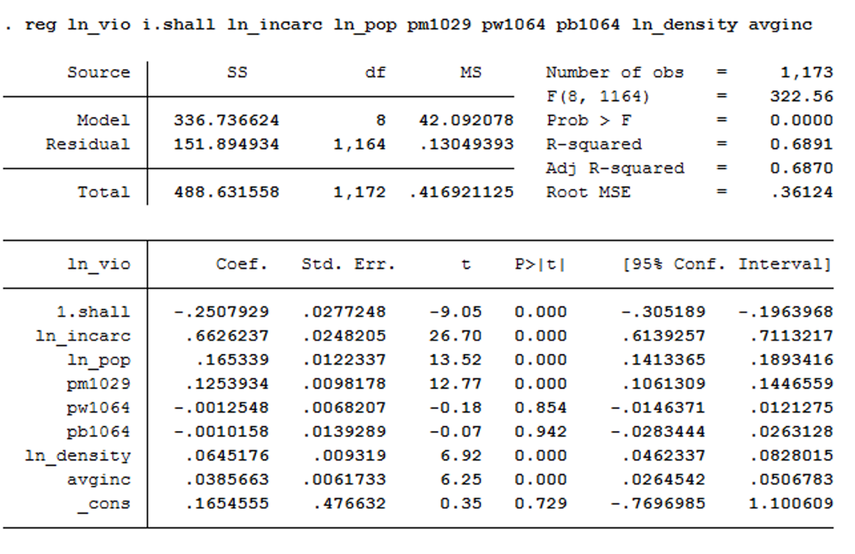

Figure 41

* Most of the independent variables have significant estimates at 5% level of significance except pw1064 and pb1064.

1. *Testing the above model for heteroscedasticity using white test:*

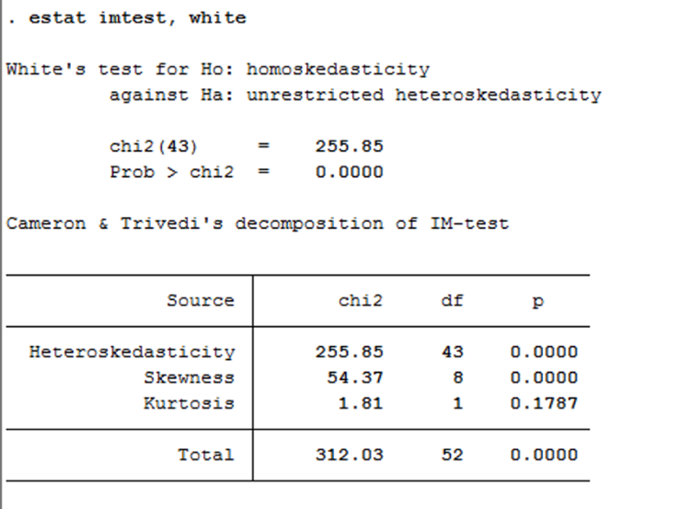

Figure 42

1. From the above white test, it can be observed that p-value is approximately zero. Hence, we reject the null hypothesis and conclude that errors are heteroskedastic.
2. Based on this conclusion, we cannot use the same standard errors formula to calculate the errors because this formula gives biased and inconsistent standard errors.
3. *Pooled OLS with cluster robust standard errors (log(vio) – dependent variable):*

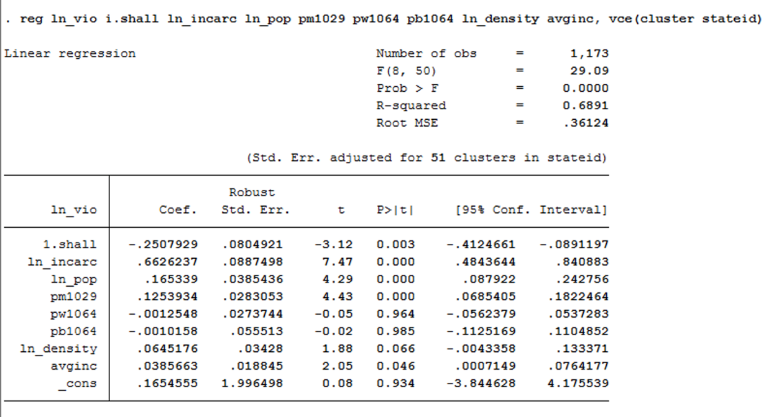

Figure 43

**­­**Based on above estimates, the following conclusions are made:

1. *Shall law:* States with shall law have 25% less violent crime rate when compared to states that do not have shall law.
2. *Incarceration Rate:* Every 1% increase in incarceration rate leads to an increase of 66.2% in violent crime rate.
3. *Population:* Every 1% increase in population leads to an increase of 16.5% in violent crime rate.
4. *Pm1029:* Every 1% increase in male population, age 10 to 29, leads to an increase of 12.5% in violent crime rate.
5. *Pb1064, pw1064:* Estimates for both these variables are insignificant and coefficient estimates are zero. Both these variables have a high negative correlation.
6. *Density:* Every 1% increase in population density leads to an increase of 6.4% in violent crime rate. This result is significant at 10% level of significance.
7. *Income:* Every $1000 increase in average income leads to an increase of 3.8% in violent crime rate.

Although this model provides us with some significant results, we cannot ignore the fact that this model suffers from endogeneity. If the model suffers from endogeneity, then coefficient estimates from this model are biased and inconsistent. These estimates will never converge to the true parameters and cannot be interpreted properly.

*Reasons for endogeneity:*

1. *Simultaneous causality bias between log(vio) and shall*: we believe that not only implementing shall law can have impact on violent crime rate but also the decision of introducing shall law is highly impacted by if the state has a high crime rate or not.
2. *Shall variable related to error term*: we believe that the introduction of shall law also depends on the cultural attitudes of the state as well as their beliefs of carrying gun or not.
3. *Unobserved heterogeneity between individuals:* like cultural beliefs, historical practices of carrying guns, other crime related state laws etc.
4. *Fixed effects estimator (log(vio) – dependent variable):*

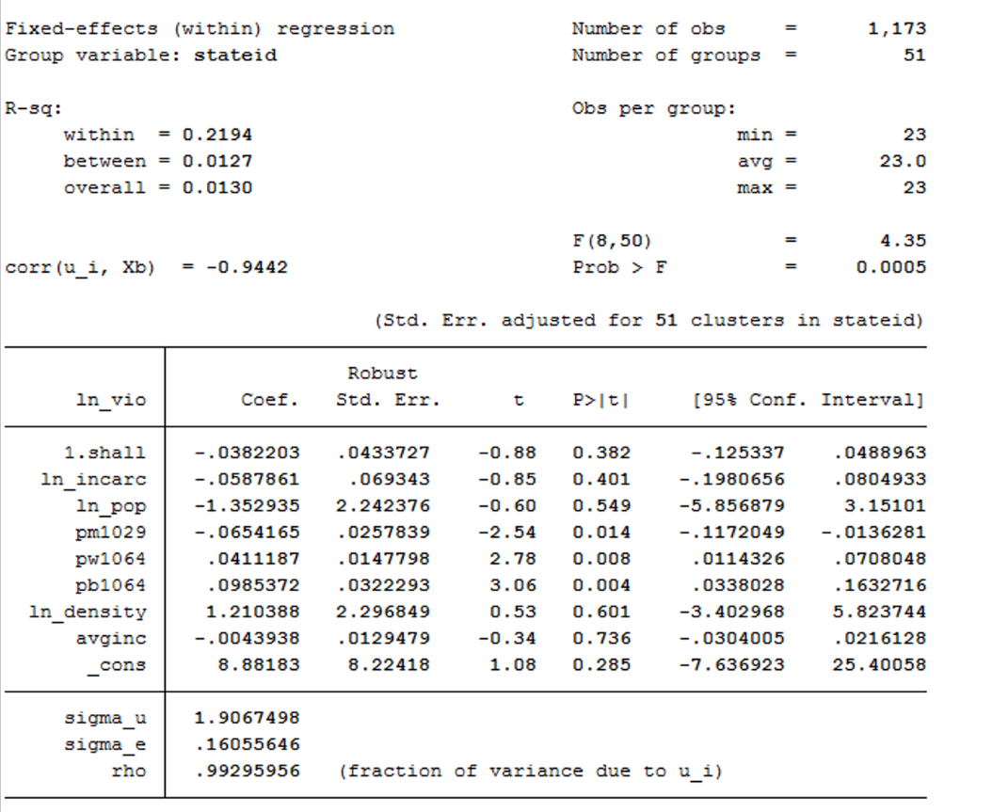

Figure 44

* It can be observed from the current and previous models that the standard error estimates have a big difference.

1. *Performing a Hausman test between pooled OLS without cluster robust with cluster robust standard and fixed effects estimator:*

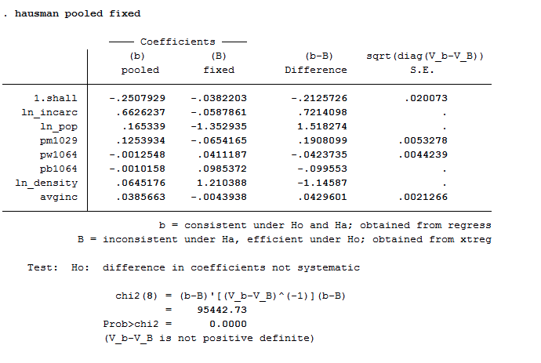

Figure 45

*H0: No endogeneity*

*H1: Endogeneity exists*

* From these test results, it can be observed that the p-value is approximately zero. Hence, we reject the null hypothesis and conclude that endogeneity exists.
* Moving forward, we will be using fixed effects estimator to get unbiased and consistent estimators. Due to endogeneity, pooled OLS estimates are inconsistent and they will not converge to the true parameters as we increase the sample size.

*Adding Quadratic and Interaction terms*:

* 1. *Quadratic Terms:*
* *Avginc*: we believe that as the average income of the state increases, the crime rate is expected to increase initially. If the average income of the state becomes very high, then we can say that most of the residents are making good money on an average and then there is less motivation to commit crimes like robbery, murder or violence.
* *Pb1064*: we believe and also it was evident from the dataset, that initially the violent crime rate and robbery rate increases as the population of black increases but after a level, the crime rate starts decreasing.

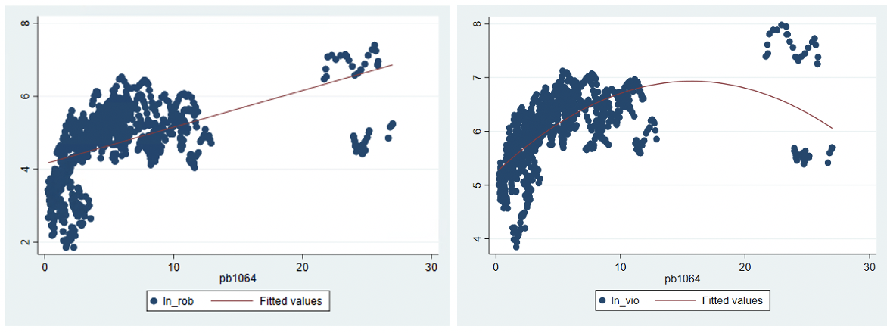

Figure 46

* *Pw1064*: Similarly, for percentage of white population in the dataset, it was evident that initially the violent crime and robbery rate increases briefly and then goes to a steady decline as the percentage reaches above 50%-60%

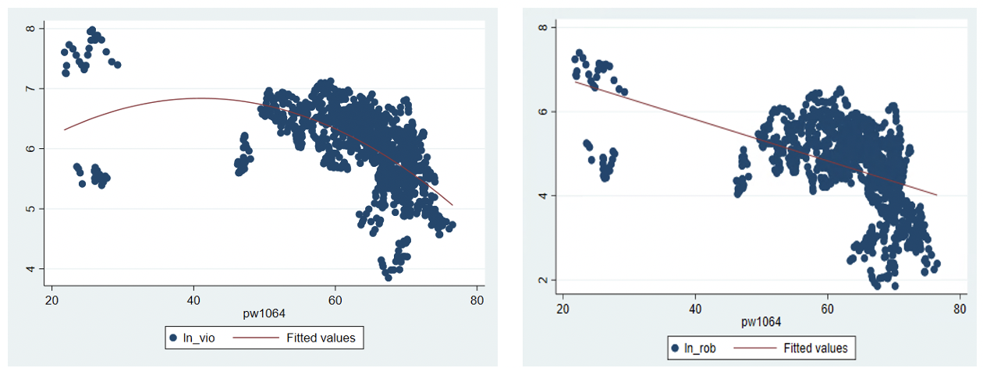

Figure 47

* 1. *Interaction Terms*:
* Incarceration rate:
  1. *Population, density, male population*: we believe that as the population or density of any state increases, the incarceration rate will likely go up. Similarly, if the young male population percentage increases, the incarceration rate will go up. (indirectly related to crime going up).
  2. *White and black population percentage*: with increase in white population, the incarceration rate is expected to go down and with increase in black population, the incarceration rate is expected to go up. This theory is based on the racial injustice prevalent in United States and how historically black population is more likely to be imprisoned.
  3. *Avginc*: with increase in average income of any state, the crime rate is expected to go down overall and therefore, the incarceration rate is also expected to go down.
  4. *Shall law*: this term is added to verify if there is any synergy effect between incarceration rate and introduction of shall law.
* Average Income:
  1. *Population, density, male population:* It is expected that the average income of the state will increase as the population or density will go up. Also, as the male population increases, it is expected that the average income will also increase.
  2. *White and black population:* states with majority of white population is expected to have higher average income and states with majority of black population is expected to have lower average income. This expectation is based on common knowledge that black population is paid lower than white population in United States on an average.
  3. *Shall law:* this term is added to check if having higher or lower average income in a state impacts their decision to implement shall law vs not.
* Population black and white:
  1. *Population, density, male population:* this term is added to verify if in this dataset the increase in population or density is more inclined towards increasing white population or black population. Similarly, if male population percentage is increasing, then is it positively correlated with black population or white population in this dataset.
  2. *Interaction between white and black population:* this term is added to check the correlation between majority of white or black population and its impact on violent crime rate.
  3. *Shall law:* this term is added to check if introduction of shall law is more likely in a state where majority population is black or white and also what is the impact of this on the violent crime rate.
* Population of a state
  1. *male population:* this term is added to check for any synergy effect on crime rate by increasing both population and male population and vice versa.
  2. *density:* similarly, this term is added to check for any synergy effect on crime if the population and population density both increases. It is expected that if the population of the state increases but density is low, then crime rate may not increase as much as if the density is also high. This is because it is easier to commit crime when an area is densely populated and the resources are also less to share among the residents.
  3. *Shall law:* this is to verify if the population of a state is high, does that impact their decision of introducing shall law and similarly, what is the impact on crime rate.

In conclusion, quadratic terms will be added for 3 variables – pw1064, pb1064 and avginc. The names of these new variables are – pb2, pw2 and avginc2. And most of the variable’s combinations are added as interaction terms to avoid any missing synergy effects from the model.

1. *Fixed effects estimator (log(vio) – dependent variable), after adding interaction terms:*

After adding interaction terms for all variables and conducting F-tests, the following model is the best model:

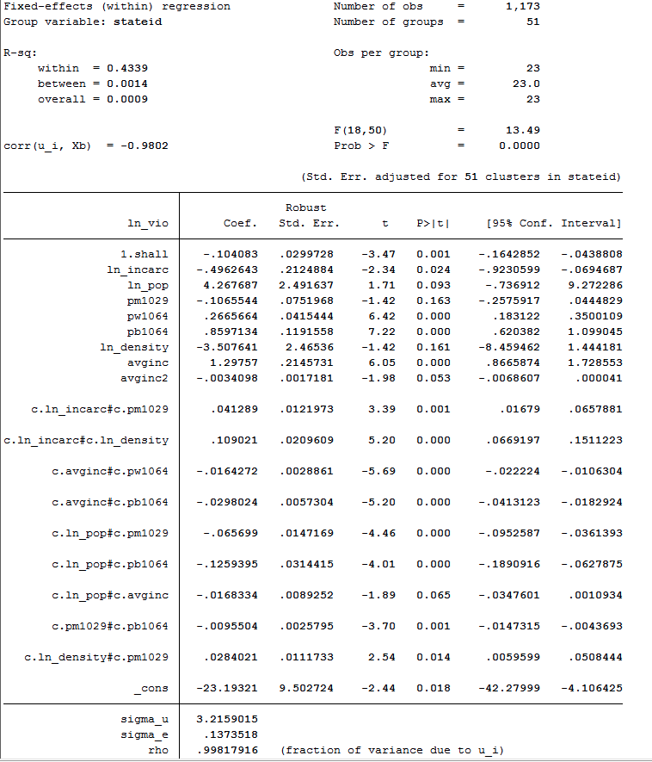



Figure 48

* From the above estimates, it can be observed that coefficient estimates for log(pop), pm1029, log(density), avginc2 and interaction between state population and average income are all insignificant at 5% level of significance.

1. *Time fixed effects estimator (log(vio) – dependent variable):*

*Reference group: year 1977*

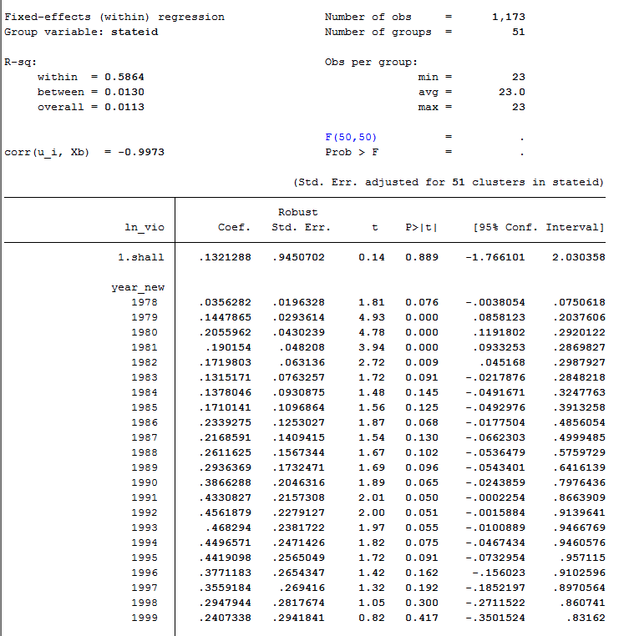

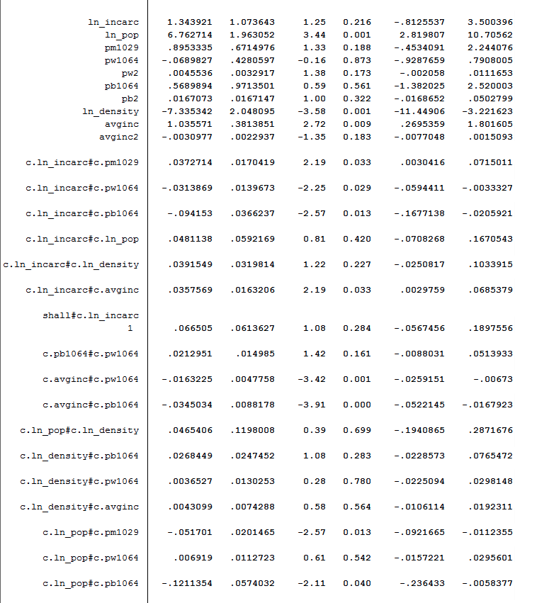

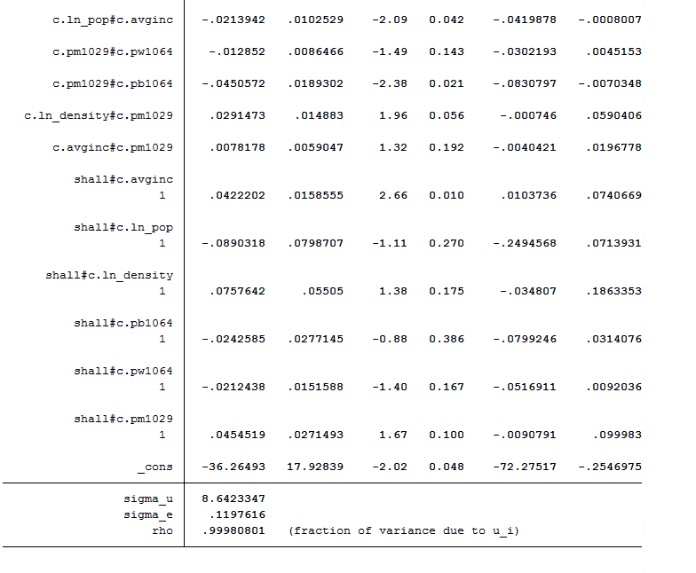

Figure 49

* 1. *Testing the significance of adding time effects:*

In order to understand if the violent crime rate is being impacted by adding the years 1977 – 1999 to the model, a joint hypothesis F-test is conducted on the coefficient estimates for the years to see if they are significant.

H0: None of the coefficient estimates for year variables are significantly different from zero.

H1: At least one of the coefficient estimates for the year variable is significantly different from zero.

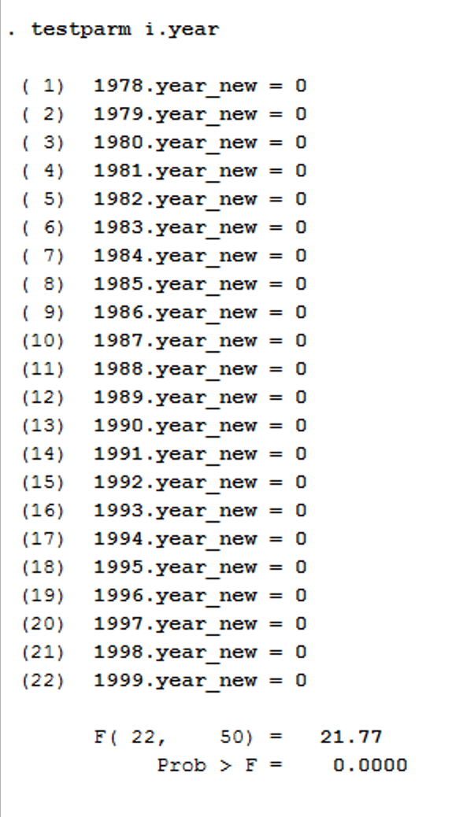 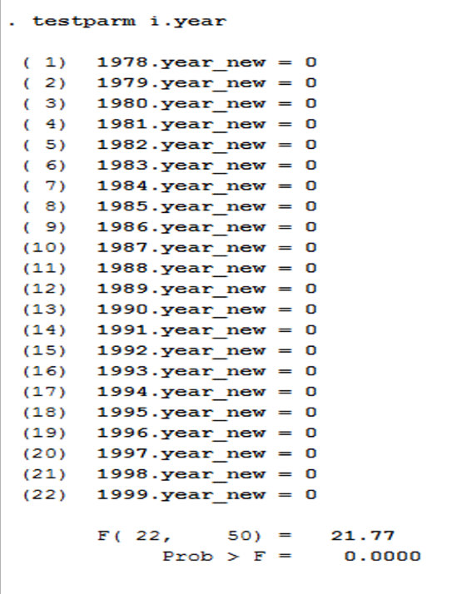

Figure 50

* From the test above, it is observed that p-value is approximately zero. Hence, we reject the null hypothesis and conclude that at least one of the coefficients estimates for year variable is significantly different from zero.
  1. *Marginal effect of log of incarceration rate:*

Test the hypothesis that if the marginal effect of log of incarceration rate on log of violent crime rate in the above model is zero**

H0: Coefficients for shall*ln_incarc, ln_incarc*ln_pop, ln_incarc*pw1064 = 0

H1: At least one of the coefficients is not equal to zero

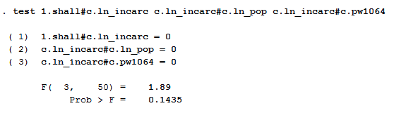

Figure 51

* It can be observed that the p-value is quite big; 0.1435. Hence, we fail to reject the null hypothesis and conclude that all these coefficient estimates are equal to zero and we can drop the above-mentioned interaction terms.

*\*\*Note: initially all the variables are added to the test. Variables are dropped from joint test based on their significance till the final f test is added to the report with only insignificant variables.*

* 1. *Marginal effects for state population:*

Test the hypothesis that if the marginal effect of log of state population on log of violent crime rate in the above model is zero**

H0: Coefficients for shall*ln_pop, ln_density*ln_pop, ln_pop*pw1064 = 0

H1: At least one of the coefficients is not equal to zero

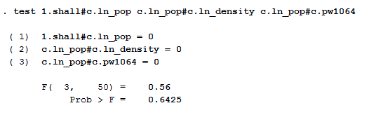

Figure 52

* It can be observed that the p-value is quite big; 0.6245. Hence, we fail to reject the null hypothesis and conclude that all these coefficient estimates are equal to zero and we can drop the above-mentioned interaction terms.

*\*\*Note: initially all the variables are added to the test. Variables are dropped from joint test based on their significance till the final f test is added to the report with only insignificant variables.*

* 1. *Marginal effect for pm1029:*

Test the hypothesis that if the marginal effect of pm1029 on log of violent crime rate in the above model is zero**

H0: Coefficients for pm1029, pm1029*pw1064, pm1029*avginc, pm1029*1.shall = 0

H1: At least one of the coefficients is not equal to zero

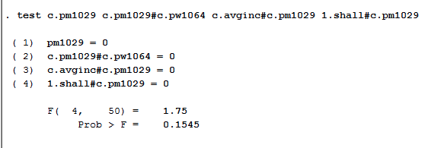

Figure 53

* It can be observed that the p-value is quite big; 0.1545. Hence, we fail to reject the null hypothesis and conclude that all these coefficient estimates are equal to zero and we can drop the above-mentioned interaction terms.

*\*\*Note: initially all the variables are added to the test. Variables are dropped from joint test based on their significance till the final f test is added to the report with only insignificant variables.*

* 1. *Marginal effect for pw1064:*

Test the hypothesis that if the marginal effect of pw1064 on log of violent crime rate in the above model is zero**

H0: Coefficients for pw1064, pw2, pb1064*pw1064, pw1064*ln_pop, pm1029*1.shall, ln_density*pw1064 = 0

H1: At least one of the coefficients is not equal to zero

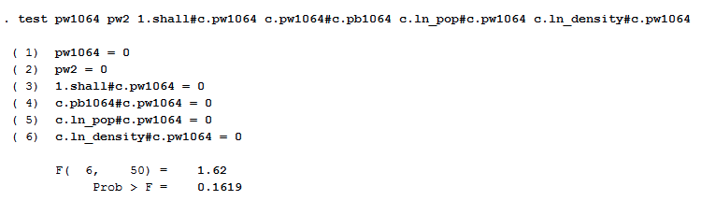

Figure 54

* It can be observed that the p-value is quite big; 0.1619. Hence, we fail to reject the null hypothesis and conclude that all these coefficient estimates are equal to zero and we can drop the above-mentioned interaction terms.

*\*\*Note: initially all the variables are added to the test. Variables are dropped from joint test based on their significance till the final f test is added to the report with only insignificant variables.*

* 1. *Marginal effect for pb1064:*

Test the hypothesis that if the marginal effect of pb1064 on log of violent crime rate in the above model is zero**

H0: Coefficients for pb2, pb1064*pw1064, pm1029*1.shall, ln_density*pb1064 = 0

H1: At least one of the coefficients is not equal to zero

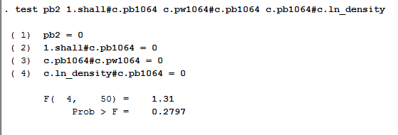

Figure 55

* It can be observed that the p-value is quite big; 0.2797. Hence, we fail to reject the null hypothesis and conclude that all these coefficient estimates are equal to zero and we can drop the above-mentioned interaction terms.

*\*\*Note: initially all the variables are added to the test. Variables are dropped from joint test based on their significance till the final f test is added to the report with only insignificant variables.*

* 1. *Marginal effect for population density:*

Test the hypothesis that if the marginal effect of log of density on log of violent crime rate in the above model is zero**

H0: Coefficients for ln_density*avginc, ln_density*1.shall = 0

H1: At least one of the coefficients is not equal to zero

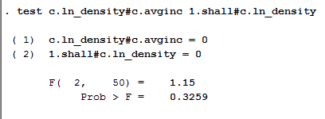

Figure 56

* It can be observed that the p-value is quite big; 0.3259. Hence, we fail to reject the null hypothesis and conclude that all these coefficient estimates are equal to zero and we can drop the above-mentioned interaction terms.

*\*\*Note: initially all the variables are added to the test. Variables are dropped from joint test based on their significance till the final f test is added to the report with only insignificant variables.*

1. *Updated time fixed effects estimator after getting rid of all the insignificant variables from the previous model:*

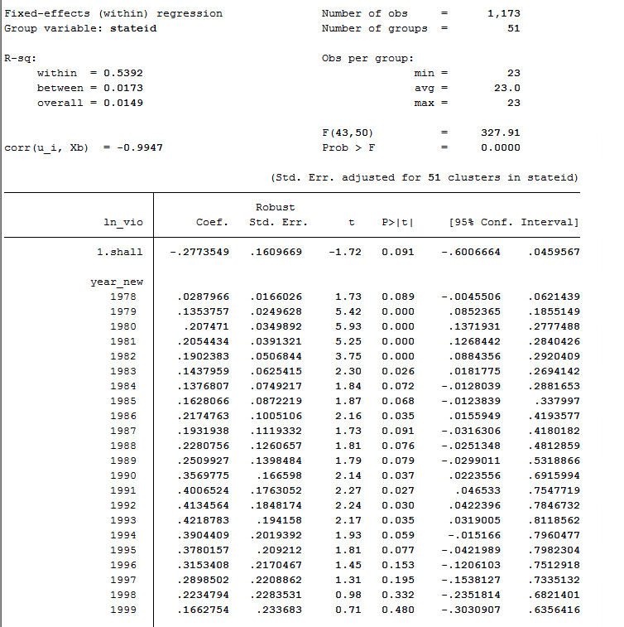



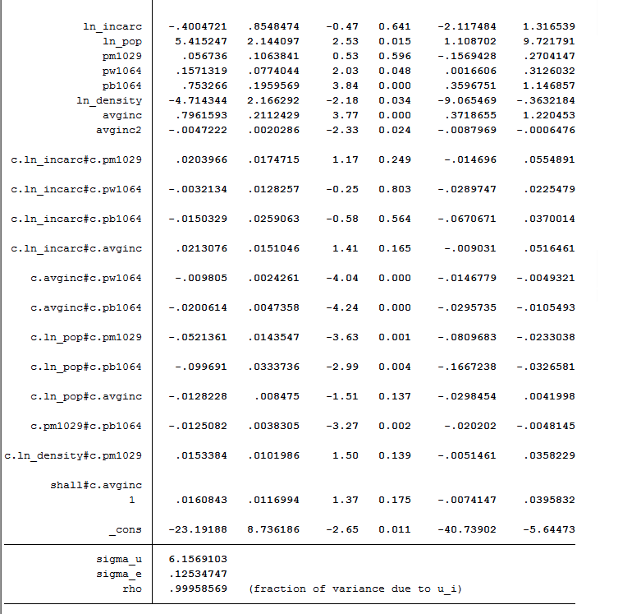

Figure 57

* It can be observed that this model still has some insignificant estimates.
  1. *Performing a joint hypothesis test for all the insignificant variables in this model*

H0: coefficients for ln_incarc*pm1029, ln_incarc*pw1064, ln_incarc*pb1064, ln_incarc*avginc, ln_pop*avginc, ln_density*pm1029, shall*avginc = 0

H1: coefficients not equal to zero

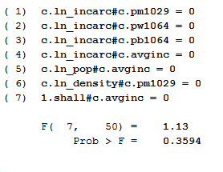

Figure 58

* It can be observed that the p-value is quite big; 0.3594. Hence, we fail to reject the null hypothesis and conclude that all these coefficient estimates are equal to zero and we can drop the above-mentioned interaction terms.

1. *Updated time fixed effects estimator after getting rid of all the insignificant variables from the previous model:* ***Best Model***

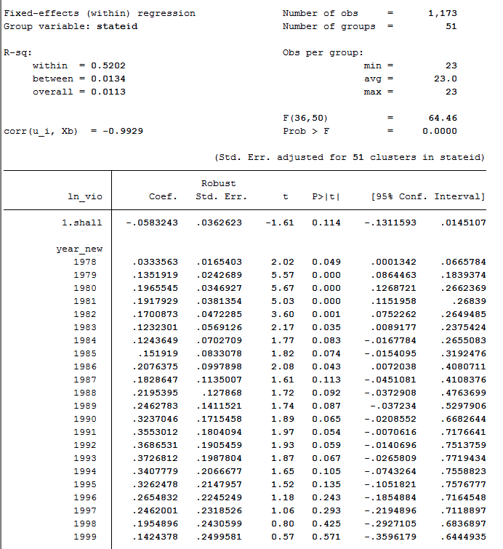

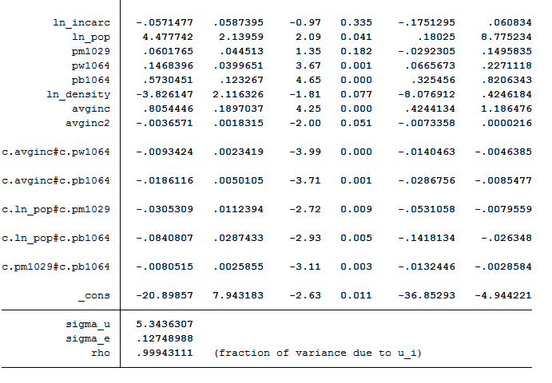

Figure 59

*Interpreting the model:*

1. *Shall:* States which have implemented shall law have 5.8% less violent crime rate in comparison to the states which have not implemented shall law. As this coefficient is not significant at 5% significance level, we cannot reject the null hypothesis that this coefficient can be zero.
2. *Year:* Most of the estimates for year variables are significant at 5% level and when compared with the reference year 1977, there seems to be an increasing trend in the violence crime rate.
3. *Incarceration rate:* If the log of incarceration rate increases by 1%, then the violent crime rate is expected to go down by .05%. This coefficient is not significant at 5% significance level which might be due to less variation in this variable within states as seen in one of the graphs in descriptive analytics. (Ref: figure 23)
4. *Population:*The impact of population on violent crime rate depends on the population percentage of males and black in the population. With increase in the percentage population of males and blacks, the positive impact of population on violent crime rate decreases.

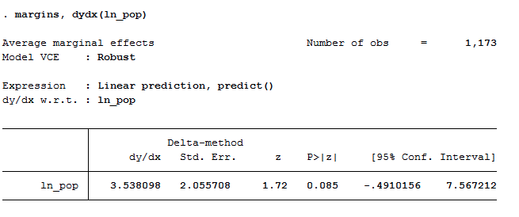

Figure 60

* Based on the estimates, marginal effect of population = 4.47 - .035*pm1029 - .084*pb1064
* The marginal effect of population shows that with 1% increase in state population, the expected increase in violent crime rate is 3.53%. This result is significant at 10% significance level.

1. *Pm1029:*

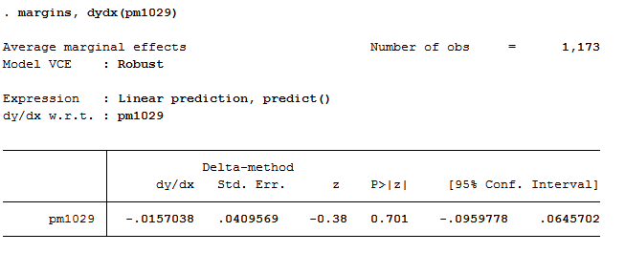

Figure 61

* The marginal effect of pm1029 shows that a 1% increase in male population in any state leads to a decrease of 1.5% in violent crime rate. This result is not significant as the p-value of 0.701 is more than significance level of 5%.

1. *Pw1069:*

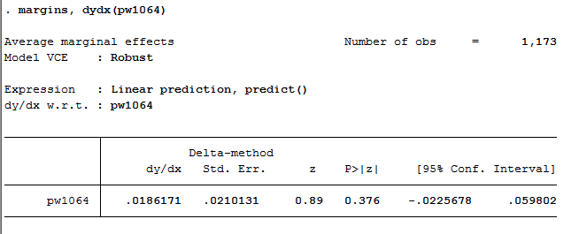

Figure 62

* The marginal effect of pw1064 shows that a 1% increase in the population of white from age 10 to 64 in any state leads to an increase of 1.8% in violent crime rate. This result is not significant as the p-value of 0.376 is more than significance level of 5%.

1. *Pb1064:*

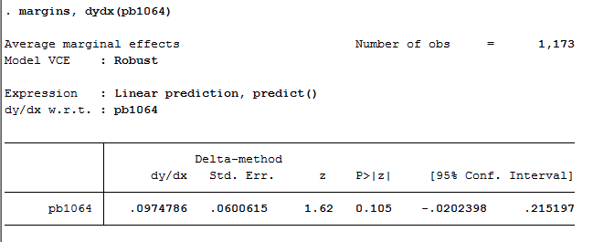

Figure 63

* The marginal effect of pb1064 shows that a 1% increase in the population of black from age 10 to 64 in any state leads to an increase of 9.7% in violent crime rate. This result is not significant as the p-value of 0.105 is more than significance level of 5%.

1. *Density:* With 1% increase in log of density of population, the violent crime rate is expected to decrease by 3.82%. This result is significant at 10% significance level.
2. *Average Income:*

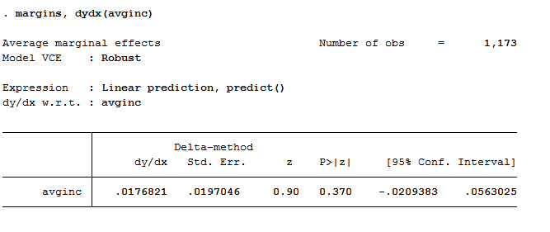

Figure 64

* With an increase of $1,000 real per capita personal income in the state, the violent crime rate is expected to go up by 1.76%. Although this result is not significant as the p-value of 0.370 is more than the significance level of 5%.

## Analysis for robbery rate:

1. *Pooled OLS without cluster robust standard errors (log(rob) – dependent variable):*

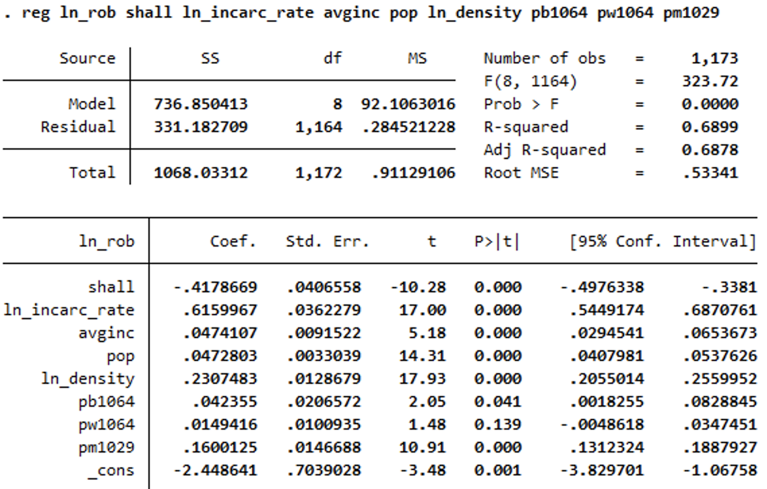

Figure 65

* Most of the independent variables have significant estimates at 5% level of significance except pw1064. We did an F-test for significance and confirmed our intuition.

1. *Testing the above model for heteroskedasticity using white test:*

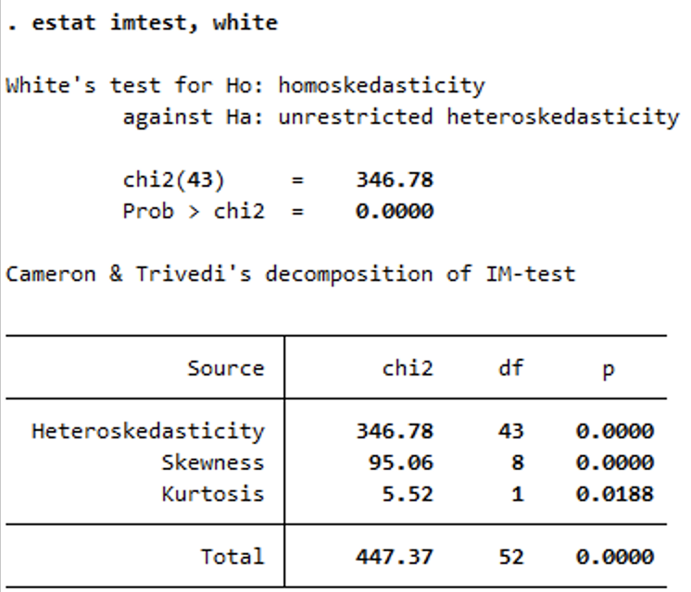

Figure 66

* 1. From the above white test, it can be observed that p-value is approximately zero. Hence, we reject the null hypothesis and conclude that errors are heteroskedastic.
  2. Based on this conclusion, we cannot use the same standard errors formula to calculate the errors because this formula gives biased and inconsistent standard errors.

1. *Pooled OLS with cluster robust standard errors (log(rob) – dependent variable):*

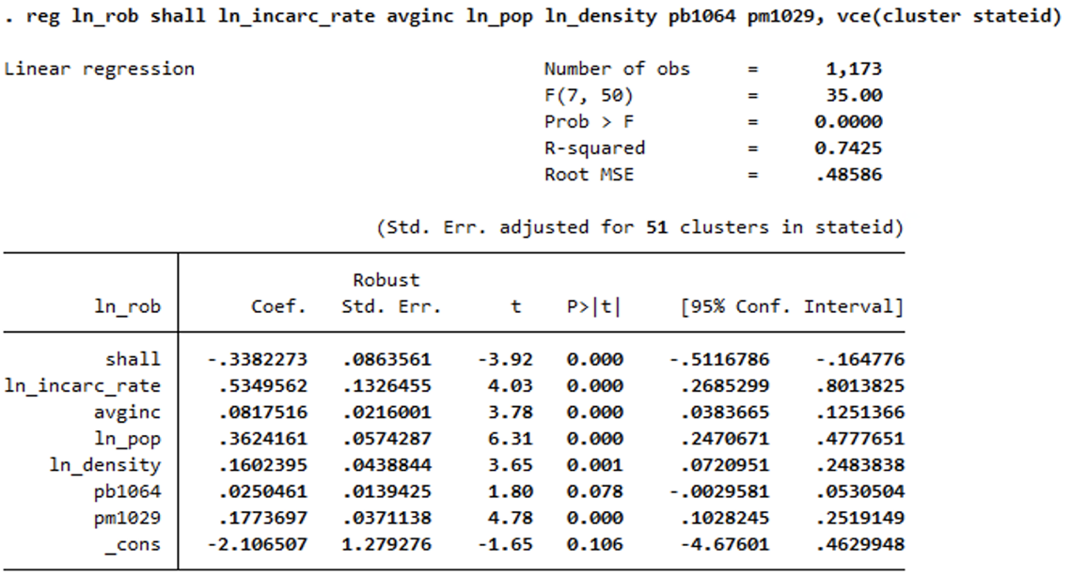

Figure 67

Based on above estimates, the following conclusions are made:

1. *Shall law:* States with shall law have 33.8% less robbery rate when compared to states that do not have shall law.
2. *Incarceration Rate:* Every 1% increase in incarceration rate leads to an increase of 53.4% in robbery rate.
3. *Population:* Every 1% increase in population leads to an increase of 36.2% in robbery rate.
4. *Pm1029:* Every 1% increase in male population, age 10 to 29, leads to an increase of 17.7% in robbery rate.
5. *Pb1064* Estimates for this variable is insignificant and coefficient estimates are 2.5%.
6. *Density:* Every 1% increase in population density leads to an increase of 16.1% in robbery rate.
7. *Income:* Every $1000 increase in average income leads to an increase of 8.1% in robbery rate.

Although this model provides us with some significant results, similar to analysis of violent crime rate, we cannot ignore the fact that this model suffers from endogeneity.

Reasons for endogeneity:

1. Simultaneous causality bias between log(rob) and shall
2. Shall related to error term; cultural attitudes dependent on a state and their notion of carrying guns
3. Unobserved heterogeneity within individuals
4. *Fixed effects estimator (log(rob) – dependent variable):*

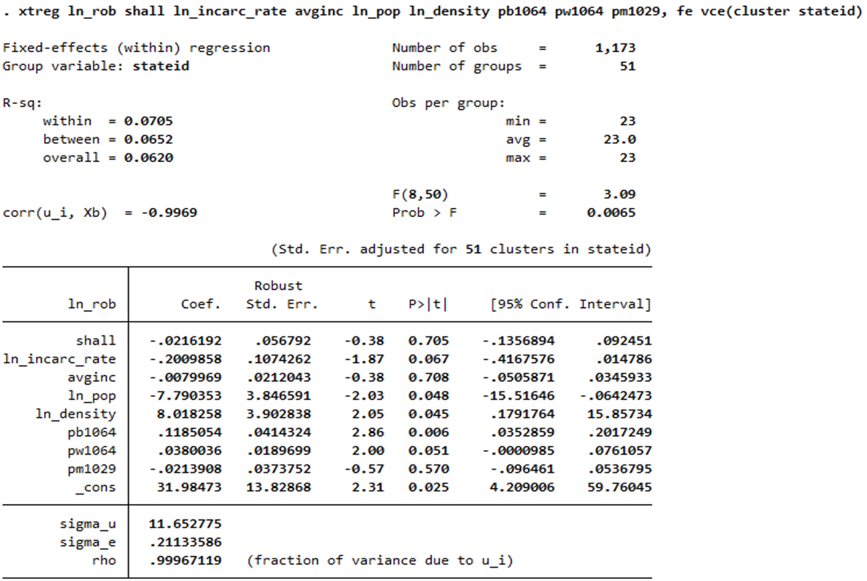

Figure 68

* It can be observed from the current and previous models that the standard error estimates have a big difference. This adds value to the point that there is unobserved heterogeneity amongst different states. We should use fixed effects, as our estimates form this model will be unbiased and consistent.

1. *Performing a Hausman test between pooled OLS without cluster robust standard and fixed effects estimator:*

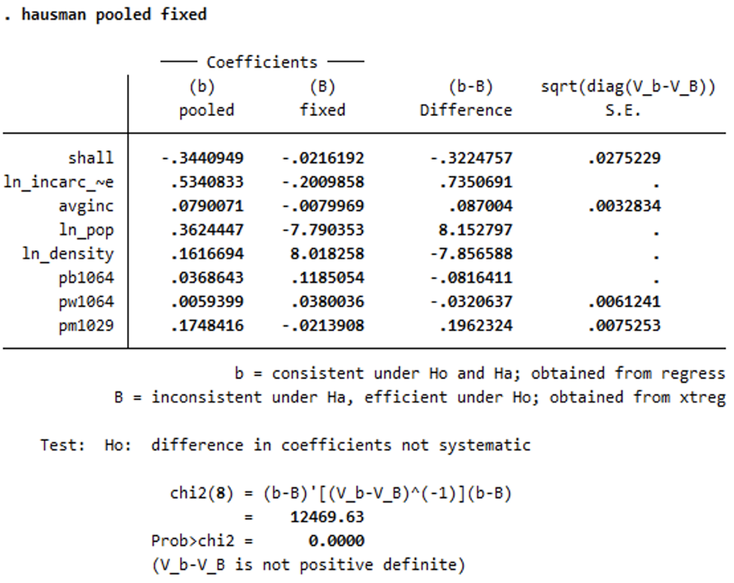

Figure 69

*H0: No endogeneity*

*H1: Endogeneity exists*

* From these test results, it can be observed that the p-value is approximately zero. Hence, we reject the null hypothesis and conclude that endogeneity exists.
* Moving forward, we will be using fixed effects estimator to get unbiased and consistent estimators. Due to endogeneity, pooled OLS estimates are inconsistent and they will not converge to the true parameters as we increase the sample size.

1. *Testing for Interaction Effects on log(rob):* After adding interaction terms for all variables and conducting F-tests 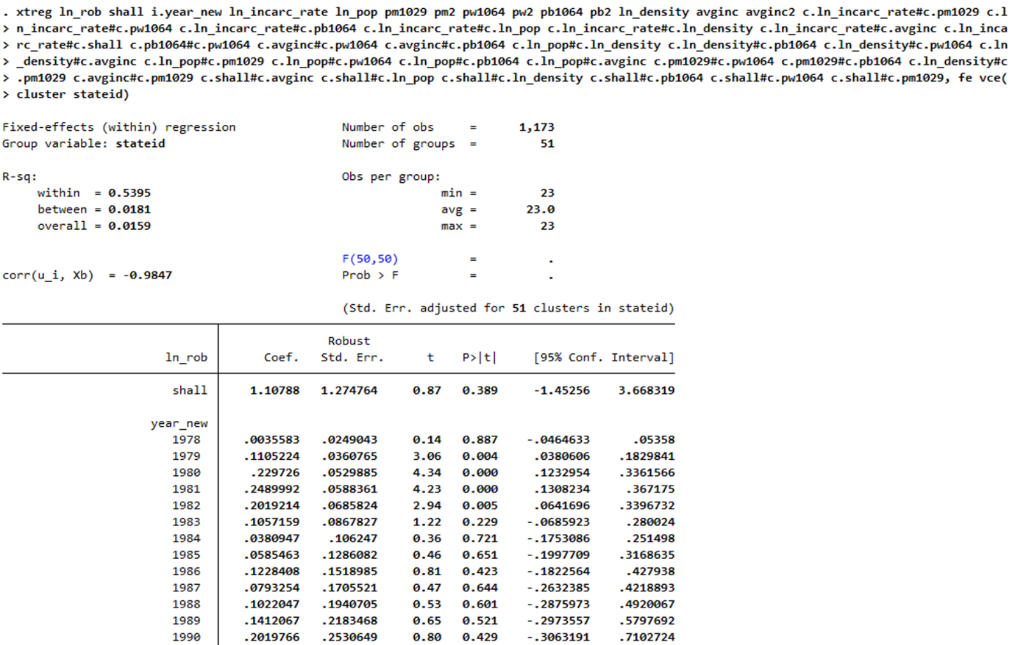 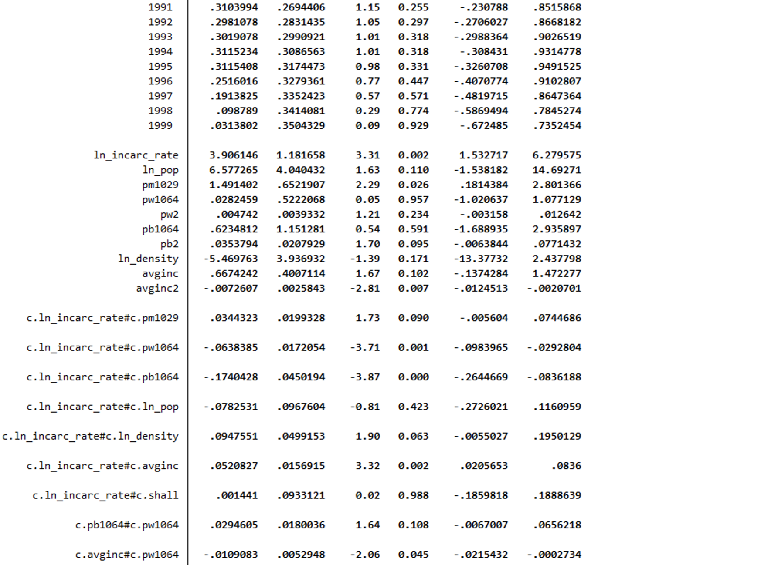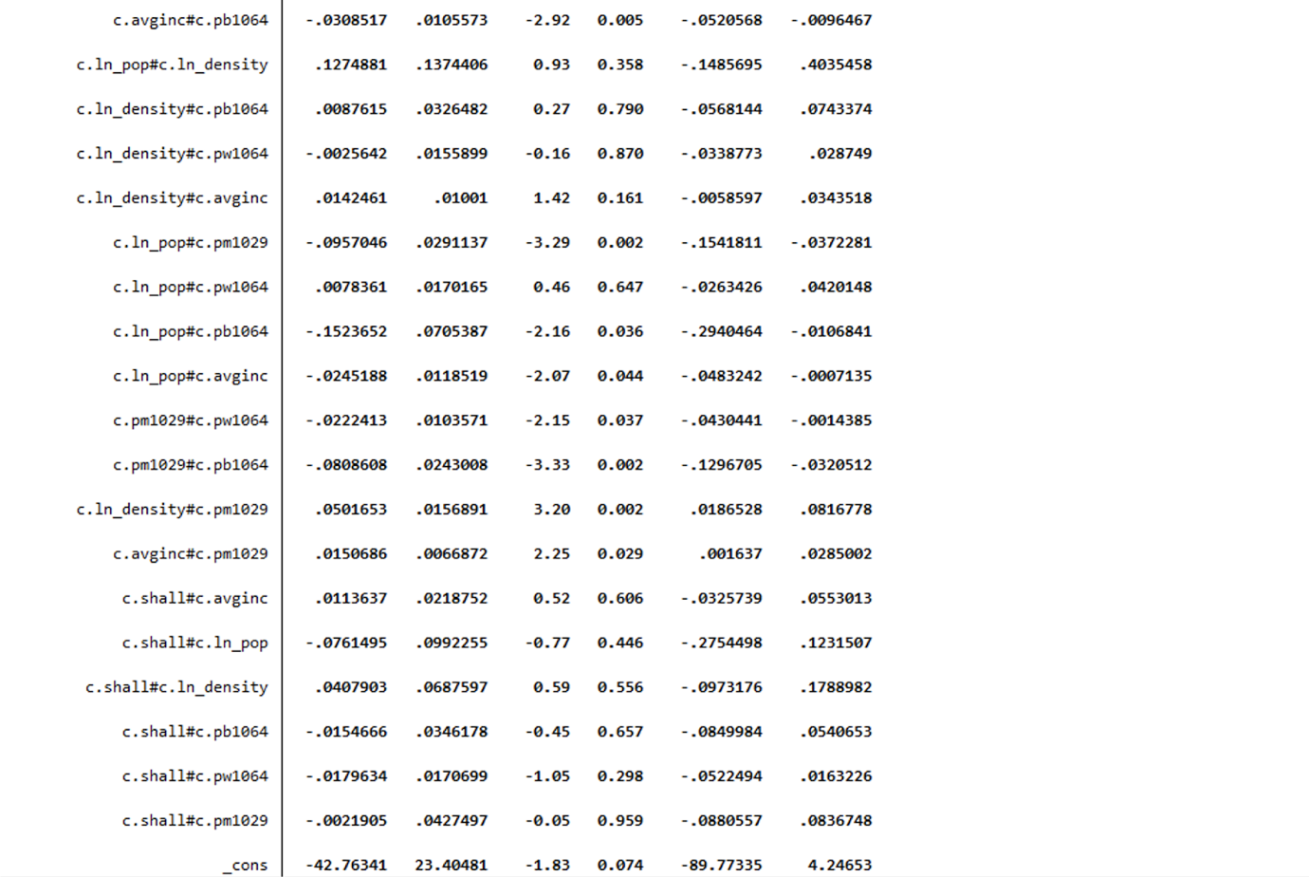

Figure 71

1. All possible interaction terms have been added to this model along with quadratic terms for average income, pb1064 and pw1064. The quadratic terms have been added to capture the diminishing effects of these variables on robbery crime rate.
2. Interaction terms for incarceration rate: We believe that incarceration rate in a state may have a synergy effect on robbery crime rate when combined with other variables like shall, state population, pm1029, pw1064 and pb1064.
3. Average income, state population, density, pm1029, pw1064, pb1064: We believe that these variables may have a synergy effect on robbery rate when combined with other variables

*Testing the significance of adding time effects: In order to understand if the robbery rate is being impacted by adding the years 1977 – 1999 to the model, a joint hypothesis F-test is conducted on the coefficient estimates for the years to see if they are significant.*

H0: None of the coefficient estimates for year variables are significantly different from zero.

H1: At least one of the coefficients estimates for the year variable is significantly different from zero.

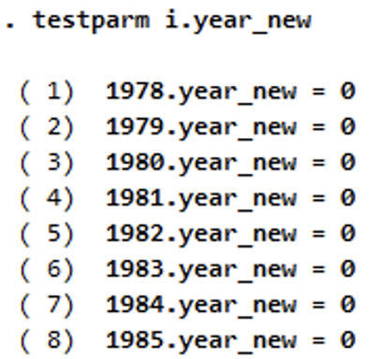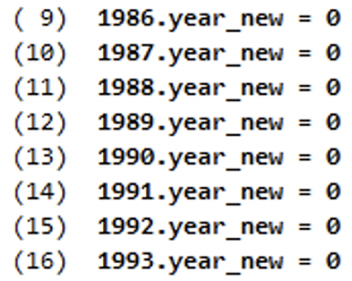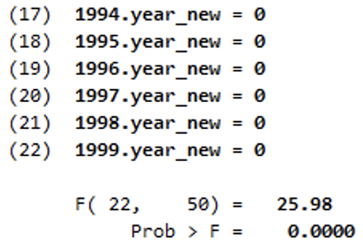

Figure 70

From the test above, it is observed that p-value is approximately zero. Hence, we reject the null hypothesis and conclude that at least one of the coefficients estimates for year variable is significantly different from zero.

* 1. *Marginal effect of log of incarceration rate:*

H0: Coefficients for ln_incarc_rate*pm1029, ln_incarc_rate*ln_density, ln_incarc_rate*shall, ln_incarc_rate*ln_pop = 0

H1: At least one of the coefficients is not equal to zero

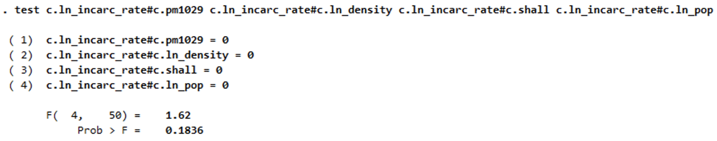

Figure 72

It can be observed that the p-value is quite big; 0.1835. Hence, we fail to reject the null hypothesis and conclude that all these coefficient estimates are equal to zero and we can drop the above-mentioned interaction terms.

* 1. *Marginal effect of log of population black and white:*

H0: Coefficients for pb1064*pw1064, pb2, pw2 = 0

H1: At least one of the coefficients is not equal to zero

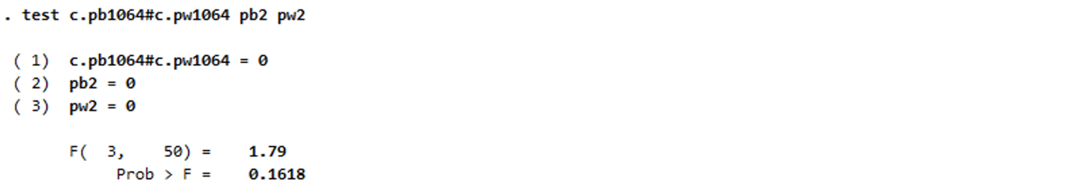

Figure 73

* 1. *Marginal effect of log of population density:*

H0: Coefficients for ln_desnity*pb1064, ln_desnity*pw1064, ln_desnity*pop, ln_desnity*avginc = 0

H1: At least one of the coefficients is not equal to zero

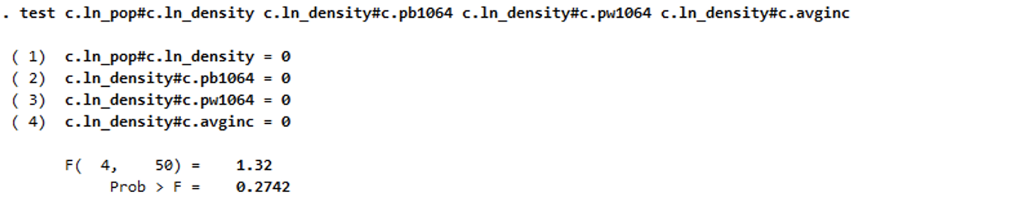

Figure 74

* It can be observed that the p-value is quite big; 0.2742. Hence, we fail to reject the null hypothesis and conclude that all these coefficient estimates are equal to zero and we can drop the above-mentioned interaction terms.
  1. *Marginal effect of log of population:*

H0: Coefficients for ln_pop*pw1064 = 0

H1: Coefficients for ln_pop*pw1064 is not 0

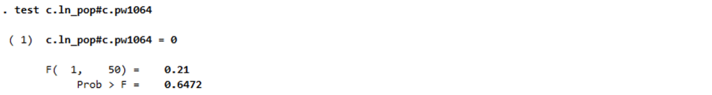

Figure 75

* It can be observed that the p-value is quite big; 0.6472. Hence, we fail to reject the null hypothesis and conclude that all these coefficient estimates are equal to zero and we can drop the above-mentioned interaction terms.
  1. *Marginal effect of shall:*

H0: Coefficients for shall*avginc, shall*ln_pop, shall*ln_density, shall*pb1064, shall*pw1064, shall*pm1029 = 0

H1: At least one of the coefficients is not equal to zero

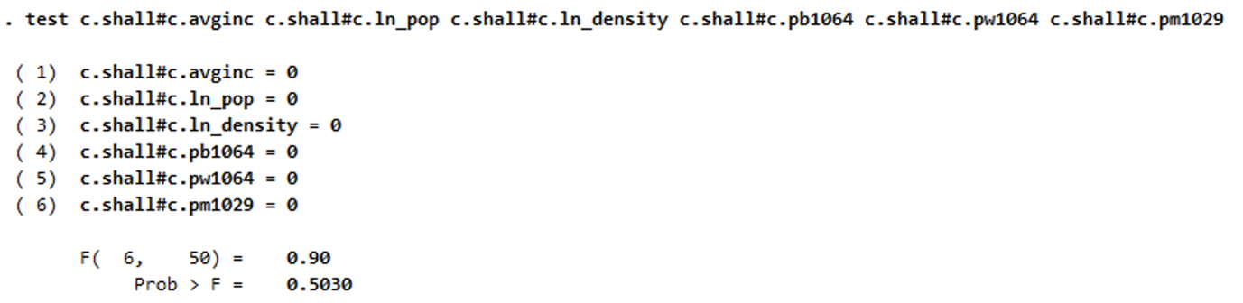

Figure 76

* It can be observed that the p-value is quite big; 0.5030. Hence, we fail to reject the null hypothesis and conclude that all these coefficient estimates are equal to zero and we can drop the above-mentioned interaction terms.

1. *Updated time fixed effects estimator after getting rid of all the insignificant variables from the previous model:*

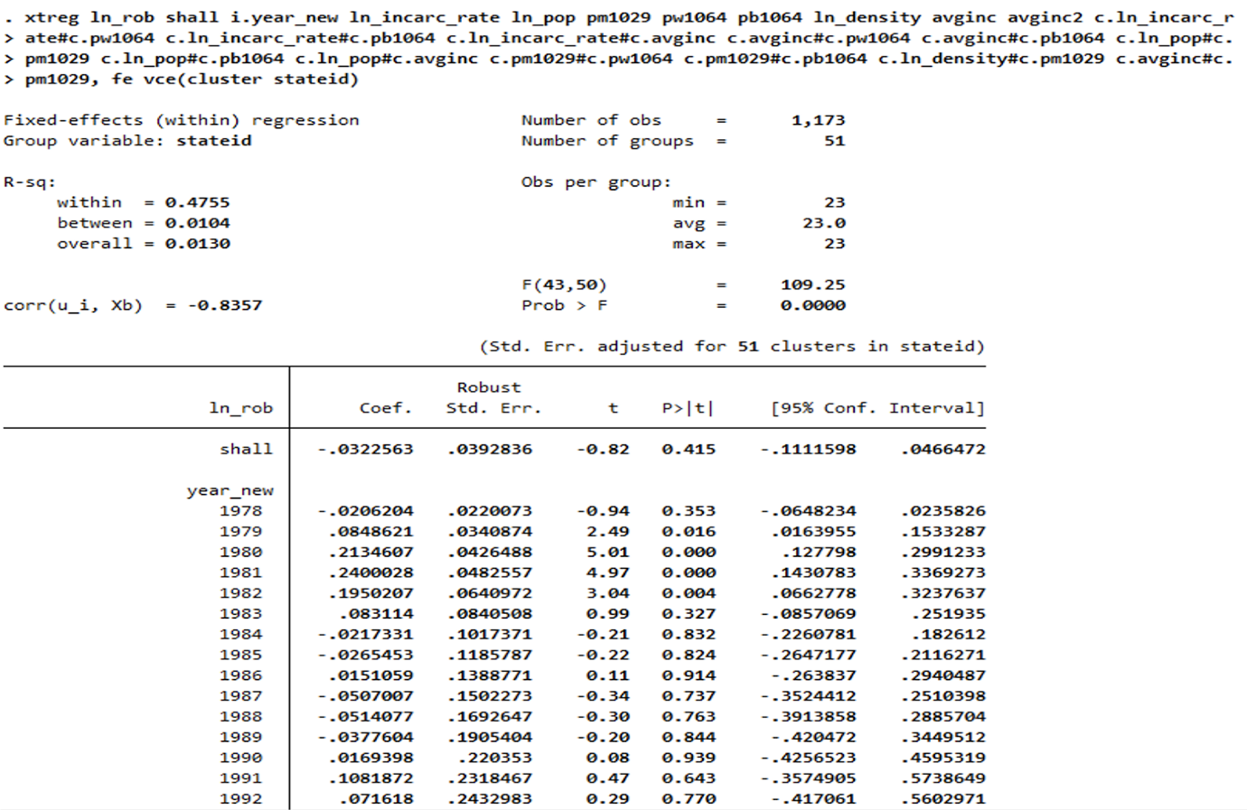

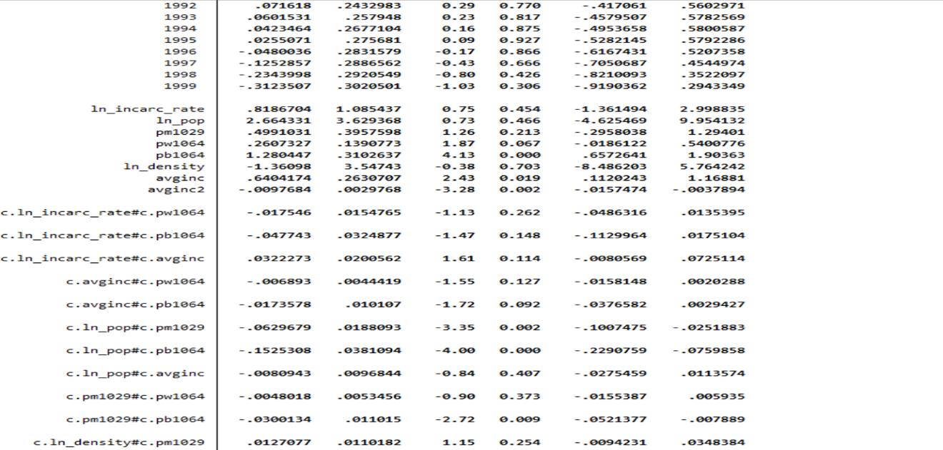 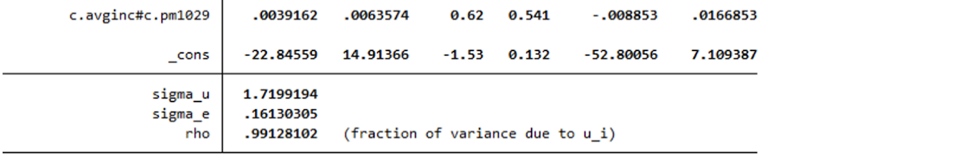

Figure 77

* It can be observed that this model still has some insignificant estimates.

1. *Performing tests for insignificant variables in this model*
2. H0: Coefficients for avginc2, ln_incarc*pw1064, ln_incarc*pb1064, ln_incarc*avginc = 0

H1: Coefficients not equal to zero

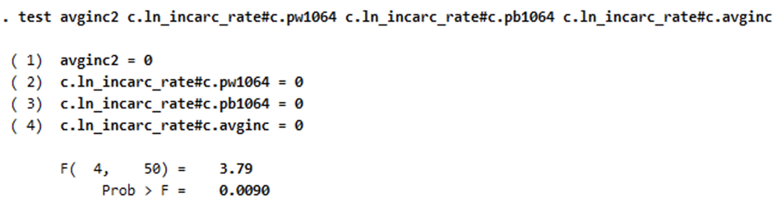

Figure 78

* It can be observed that the p-value is quite small; 0.0090. Hence, we reject null hypothesis and conclude that all these coefficient estimates are different from zero and we do not drop the above-mentioned interaction terms.

1. H0: Coefficients for avginc*pw1064, avginc*pw1064, avginc*ln_pop = 0

H1: Coefficients not equal to zero

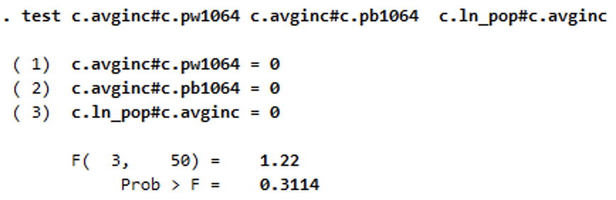

Figure 79

* It can be observed that the p-value is quite small; 0.3114. Hence, we cannot reject null hypothesis and conclude that all these coefficient effect that is not significantly different from zero. We drop these from the model.

1. H0: Coefficients for pm1029*pw1064, pw1029*ln_density, pm1029*avginc = 0

H1: Coefficients not equal to zero



Figure 80

* It can be observed that the p-value is quite small; 0.3114. Hence, we cannot reject null hypothesis and conclude that all these coefficient effect that is not significantly different from zero. We drop these from the model.

1. *Updated time fixed effects estimator after getting rid of all the insignificant variables from the previous model:*

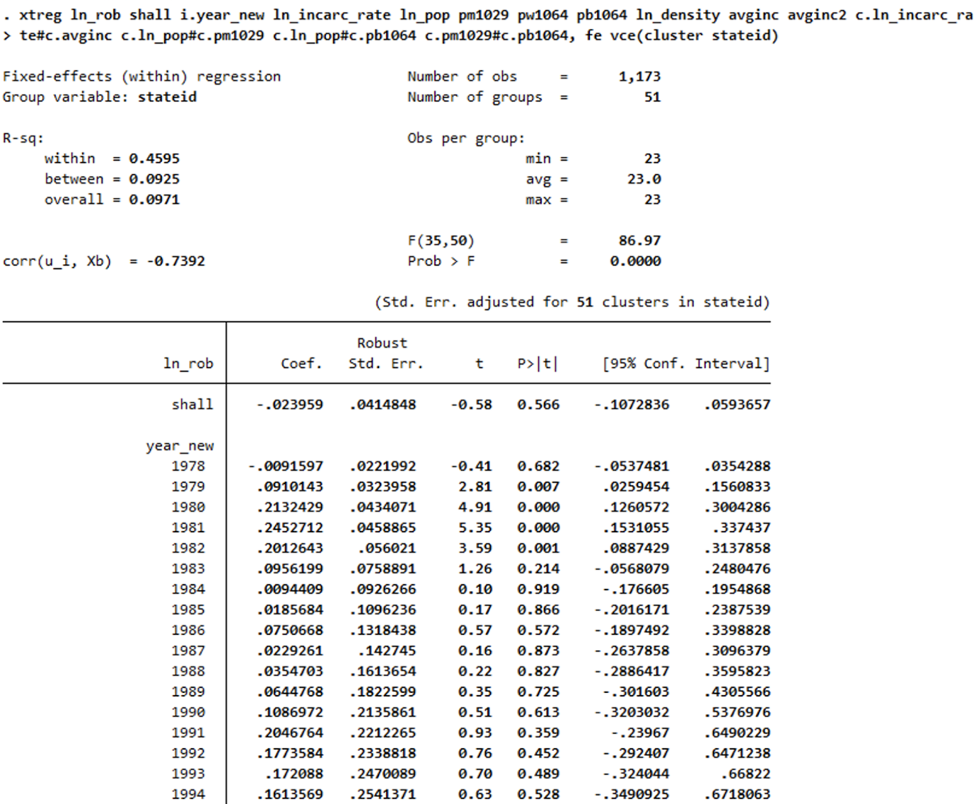

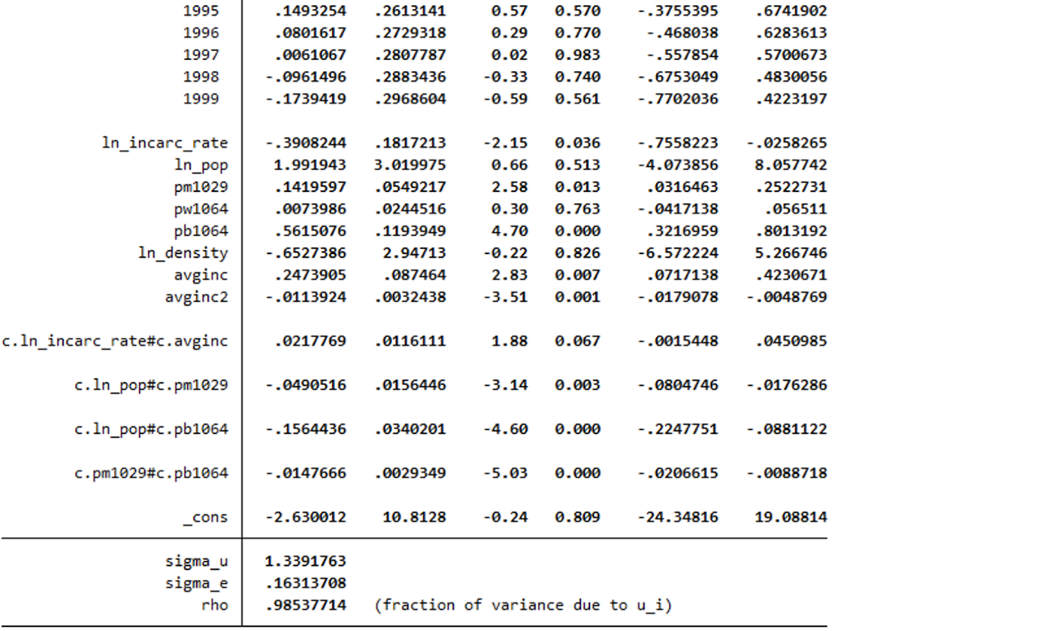

Figure 81

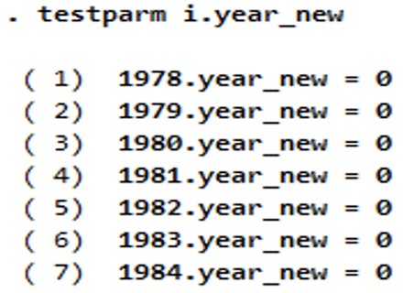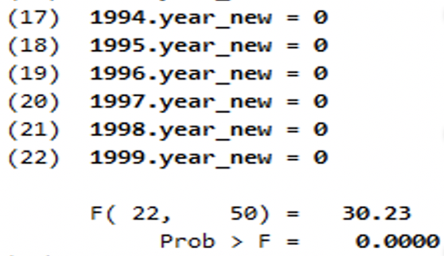

Figure 82

*Interpreting the model:*

1. *Shall:* States with shall law implemented have 2.3% less robbery rate in comparison to the states which have not implemented shall law. However, this coefficient is not significant at 5% significance level, we cannot reject the null hypothesis that this coefficient can be zero.
2. *Year:* Most of the estimates for year variables are significant at 5% level and when compared with the reference year 1977, there seems to be an increasing trend in the violence crime rate.Year variables are significant at 5% level based on the F-test conducted. The robbery rate has initially increased and then decreases after 1998.
3. *Incarceration rate:* If incarceration rate is increased by 1% then the robbery rate is expected to go down by 39.08%. This looks to be a bit too high for an acceptable change.
4. *Population:*

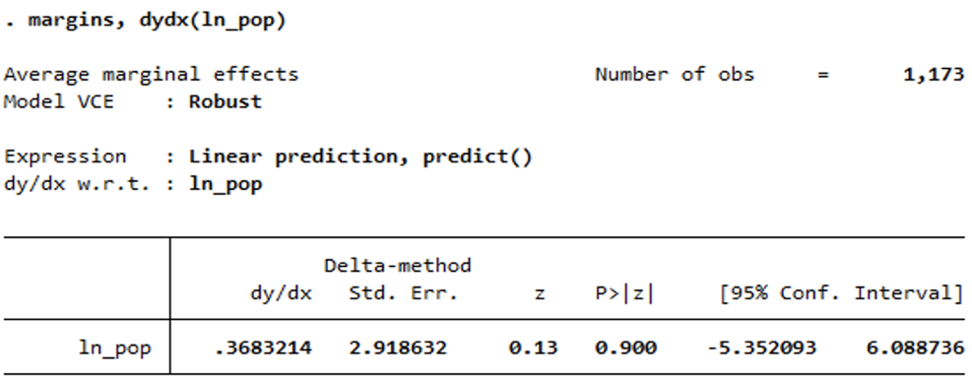

Figure 83

* The impact of population on robbery rate depends on the population percentage of males and black in the population. With increase in the percentage population of males and blacks, the positive impact of population on robbery rate decreases. Based on the estimates, marginal effect of population = 1.99 - .049*pm1029 - .156*pb1064.The marginal effect of population shows that with 1% increase in state population, the expected increase in robbery rate is 3.53%. This result is significant at 10% significance level.

1. *Pm1029:*

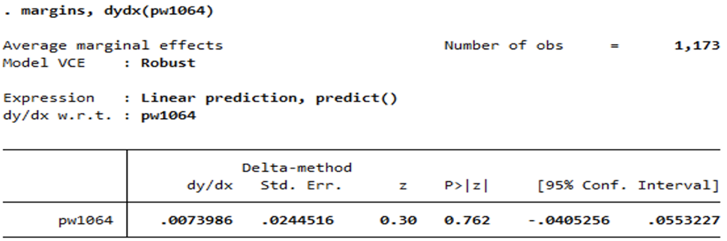

Figure 84

* The marginal effect of pm1029 shows that a 1% increase in male population in any state leads to a decrease of 1.02% in robbery rate. This result is not significant as the p-value of 0.900 is more than significance level of 5%.

1. *Pw1069:*

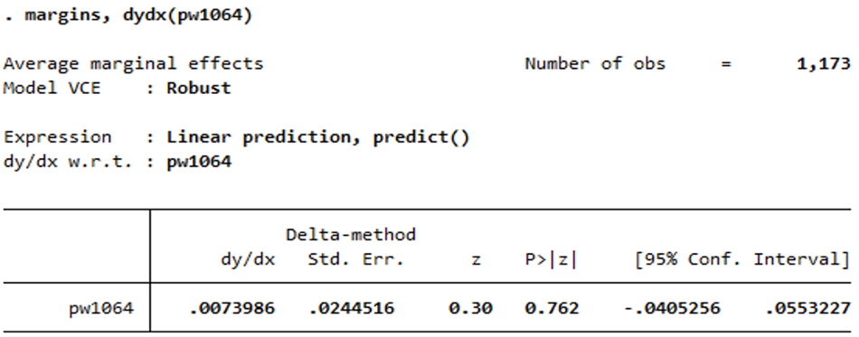

Figure 85

* The marginal effect of pw1064 shows that a 1% increase in the population of white from age 10 to 64 in any state leads to an increase of 0.74% in robbery rate. This result is not significant as the p-value of 0.762 is more than significance level of 5%.

1. *Pb1064:*

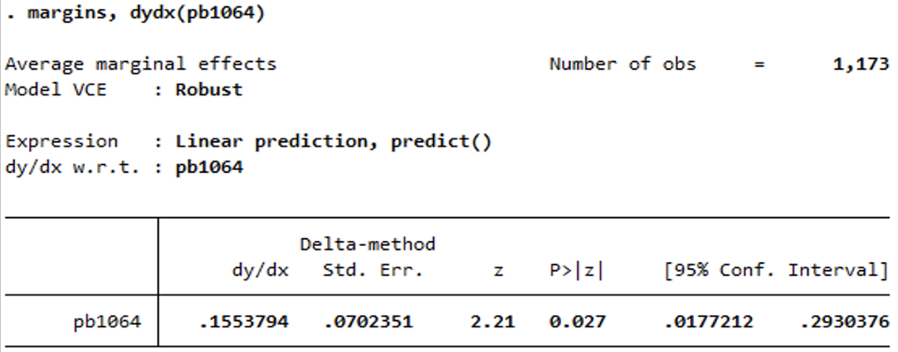

Figure 86

* The marginal effect of pb1064 shows that a 1% increase in the population of black from age 10 to 64 in any state leads to an increase of 15.5% in robbery rate. This result is significant as at significance level of 5%.

1. *Density:*

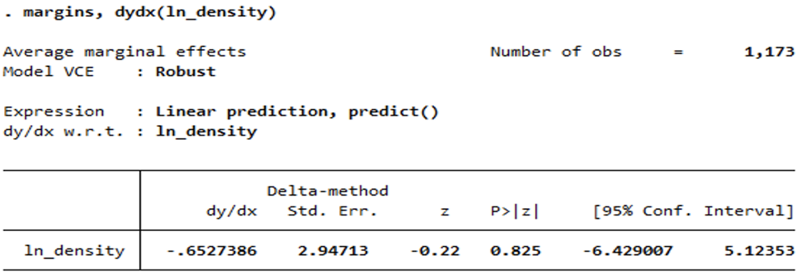

Figure 87

* With 1% increase in log of density of population, the robbery rate is expected to decrease by 65.82%. This result is not significant as the p-value of 0.825 is more than significance level of 5%.

1. *Average Income:*

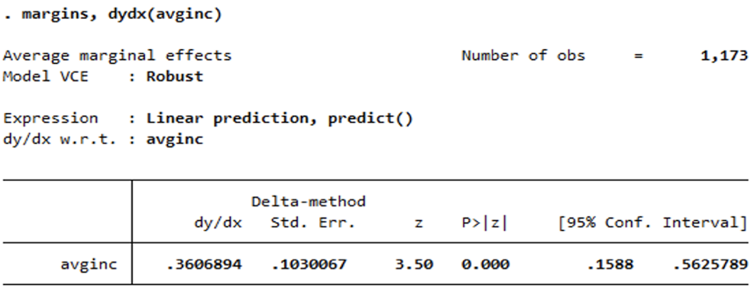

Figure 88

* With an increase of $1,000 real per capita personal income in the state, the robbery rate is expected to go up by 36.06%. Surprisingly, this result is highly significant.

## Random Effects Model:

*The reason why Random Effects model was not used as an algorithm to model this dataset:*

This data is for states rather than individuals, the data is not randomly collected, so there is no reason to use a random effects model. Also, we saw earlier that this model suffers from endogeneity and random effects models cannot solve that problem. The estimates will be inconsistent if random effects model is used for this dataset.

# Conclusion:

***For both Violent crime rate and robbery rate, “Entity and Time Fixed effects” model gives better results since it reduces both observed and unobserved heterogeneity and endogeneity.***

***Violent crime rate:*** States which have implemented shall law have 5.8% less violent crime rate in comparison to states which have not implemented shall law. However, this coefficient is insignificant at 5% significance level.

***Robbery rate:*** States with shall law implemented have 2.3% less robbery rate in comparison to the states which have not implemented shall law. However, this coefficient is insignificant at 5% significance level. Therefore, we have inconclusive results that shall-carry law has any impact on reducing violent crime rate or robbery rate.